Linguistic Insights!
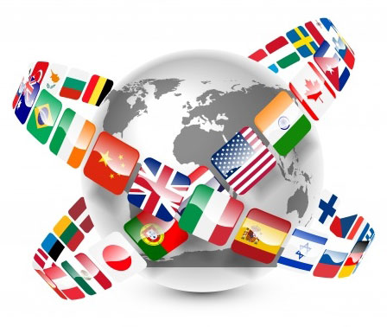

When: January 22, 2015
Time: 3-5 pm
Place: Culture Connection
Walker Hall (2-101)

Activities include:
*Different Language Alphabets – Discover your name as written in multiple languages using different internet programs.
*Words of Respect: Explore the diversity of languages and ethnic groups in your state and identify group of words and terms from various cultures that are commonly used.

*Linguistics/Language Exercise: Explore the linguistic and cultural composition of the US by looking at the Modern Language Association Language Map
