USA Funds Life Skills Student Guide
University of Louisiana at Monroe, Financial Literacy

Through your school, you now have access to USA Funds® Life Skills®, a free online learning program that offers you advice for managing your time and money wisely while on campus and after graduation. This Student Guide provides basic information about the tool and outlines the steps necessary to access and complete the lesson(s) that your school has assigned to you.

Log in.
New users are required to complete a simple, one-time registration process. Once you complete the initial registration process, only your username and password are required for future visits.
- Open your browser and go to www.lifeskills.org.
  - Helpful hint: Save this address as a favorite to simplify access for future visits.
- Click “Request a new account” in the Login box to create your account.
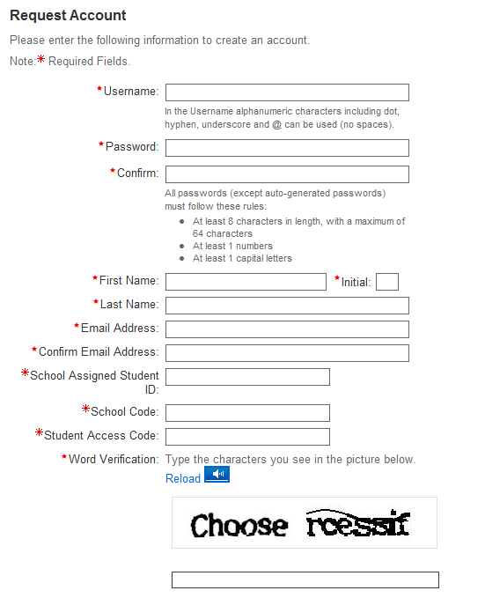
- Complete all of the information on the Request Account page. Some fields require the school defined information listed below.
  - Enter your school e-mail address as your username.
  - Enter the student ID number assigned to you by your institution as your school-assigned student ID.
  - Enter 00202000 as your School Code. Note: This code must be entered exactly as shown here.
  - Enter 00202000-01 as your Student Access Code. Note: This code must be entered exactly as shown here.
- Click “Create Account” in the lower right corner to create your account.
  - Note: If you forget your password on future visits, click “Forgot your password?” in the Login box to receive an email containing your password to the email address you provided when you created your account.

Get started.
To access and complete the lessons, follow these steps:
- Select “My Catalog” from the left navigation menu or select the “My Catalog” tab at the top of the page.
- Click on the name of a lesson and click “Enroll” on the right side of the screen.
  - Lessons can be completed in any order. If you are unable to complete a lesson in one visit, you can return to it at any time and continue where you left off. Click the name of the lesson under “My Learning” on your Home page to return to the in-progress lesson.
- Click on the name of the lesson again under “OLT Lessons” to begin the lesson.
  - Note: Your computer settings must be set to allow pop-ups to access the lesson. The lessons also contain sound so you may want to use headphones.
- Click “Next” to advance through the lesson.
- Complete the Lesson Challenge quiz at the end of the lesson. You must achieve 70 percent or higher to pass the lesson. Once achieved, your score will be recorded on your transcript as well as your school’s weekly report. (See next section for transcript information.)
  - Scroll to the bottom of the Lesson Challenge results and click “Print” to print your quiz results.
- Click “Ok” to close your quiz results and click “Close Window” to exit the lesson.
- Click USA Funds Life Skills Survey under “Course Activities” to complete a brief survey about the lesson.
- Click the “Home” tab to return to the Home page.
- Repeat the previous steps until you have completed all of the lessons assigned to you.
You can review the lessons and retake the Lesson Challenges to improve your score at any time by navigating to the lesson through the course catalog.
The curriculum covers the following topics:
- 100 level lessons will help you find resources to pay for college, understand the steps required to apply for financial aid and prepare to repay your student loans.
- 200 level lessons will help you manage your school and personal life by living on a budget, selecting the right program of study and setting career, financial and educational goals.
- 300 level lessons will help you search for a job, prepare for an interview and understand the details related to life after graduation.
- 400 level lessons will help you manage your debt including credit cards, understand credit scores and reports, protect yourself from identity theft, and maximize your savings.
- 600 level lessons will help you survive and pay for graduate school, and manage debt during school and prepare for life after graduate school.
- 700 level lessons will help couples — where at least one person is in school — balance time, money and relationships with the demands of completing graduate school.

See your results.
A printable transcript of your lesson activity is available at any time.
- Click “My Transcripts” in the left navigation menu.
  - Your transcript will provide details about any lesson in which you have enrolled, including completion status, registration date, completion date and final assessment score.
- You have the option to print or export your transcript.
  - Click “Print” in the upper right corner to print your transcript.
  - Click “Export” in the upper right corner, choose an export format and click “Export” to create an electronic version of your transcript.

Complete multiple assignments.
If you are assigned multiple lessons from different staff (for example, one group of lessons from the financial aid office and another group of lessons from a professor), you will need to enter additional access codes to your account. This is required for your lesson completion results to be accurately reported to those who assigned the USA Funds Life Skills lessons to you.
- Click “My Account” in the left navigation menu.
- Enter the additional code(s) in the available Student Access Code fields.
  - Note: If you override an existing code with a new code, your completion results no longer will be reported to the person who provided the existing code.
- Click “Update.”
Get help.
For assistance, use the “Contact Us” link or call USA Funds Customer Support, Monday through Friday, between 8 a.m. and 8 p.m. Eastern time at (800) 766-0084. After these hours, support is available at (866) 722-1470.

