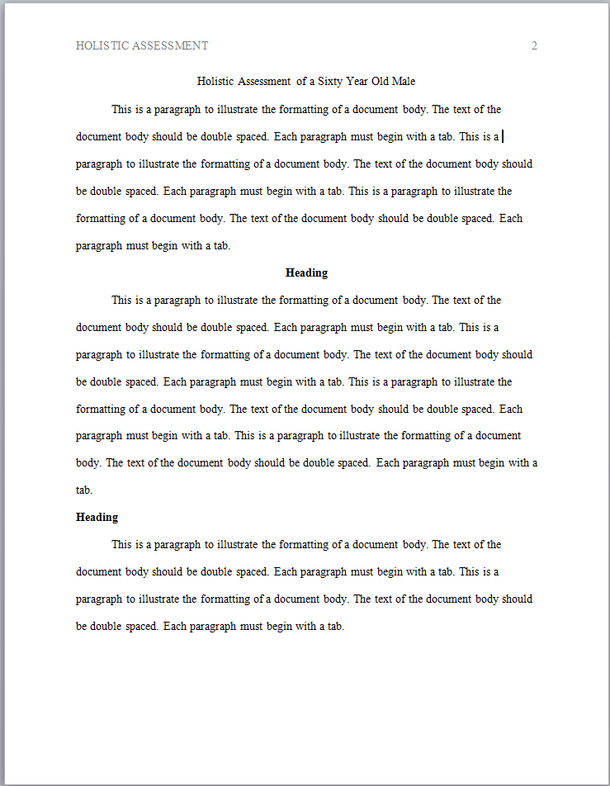
Beginning on the first page of the document body and for all subsequent pages OMIT the words "Running head:" from the header.

level One heading

Document Body Layout

Specific word processing instructions will vary according to the software and version that you are using. For detailed instructions access the HELP menu of the word processing program that you are using.
level two heading

Margins: one inch on all sides

Typeface: New Times Roman 12 pt.

Header and page number: The header (minus the words "Running head:") from the title page must appear on all pages of the document. The page number must increment.

Document specifics:

- The header on the document body page(s) should not contain the words "Running head:"
- The full title of the document must appear centered on the first line of the body
- The text must align on the left margin
- Each paragraph must begin with a tab
- Each sentence must be followed by two spaces
- Level one headings must be centered and bold
- Level two headings must be on the left margin and bold

