Same header as document body
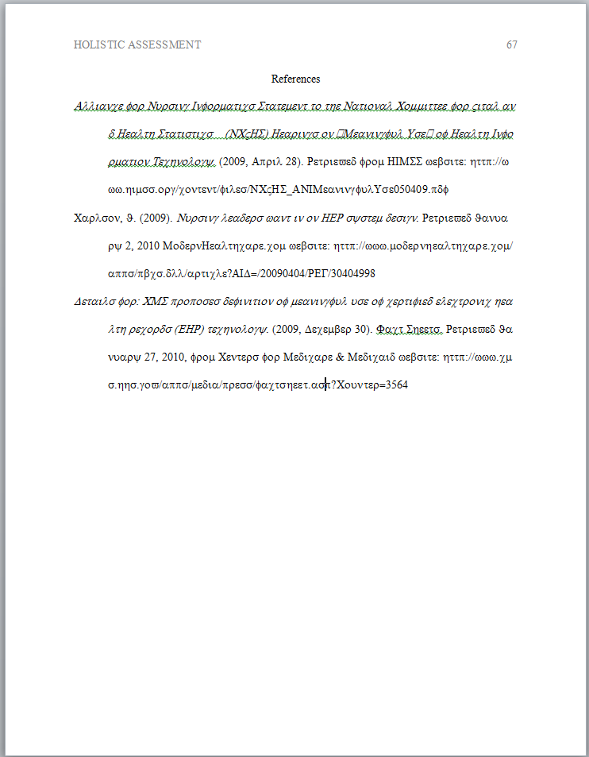

Notice the hanging indent

Reference Page Layout

Specific word processing instructions will vary according to the software and version that you are using. For detailed instructions access the HELP menu of the word processing program that you are using

Margins: one inch on all sides

Typeface: Times New Roman 12 pt.

Header and page number: The header that appears on all pages of the document body must appear on the reference page(s). The page number must increment.

Reference page specifics:

- The title of the page, References, must be centered on the first line.
- References must be double-spaced
- References must be in hanging indent format. Notice how the first line of each reference begins on the left margin and the subsequent lines are indented. Do not attempt to create this format manually! Use your word processing functions. (Go to your HELP menu and search on the words hanging indent.)

