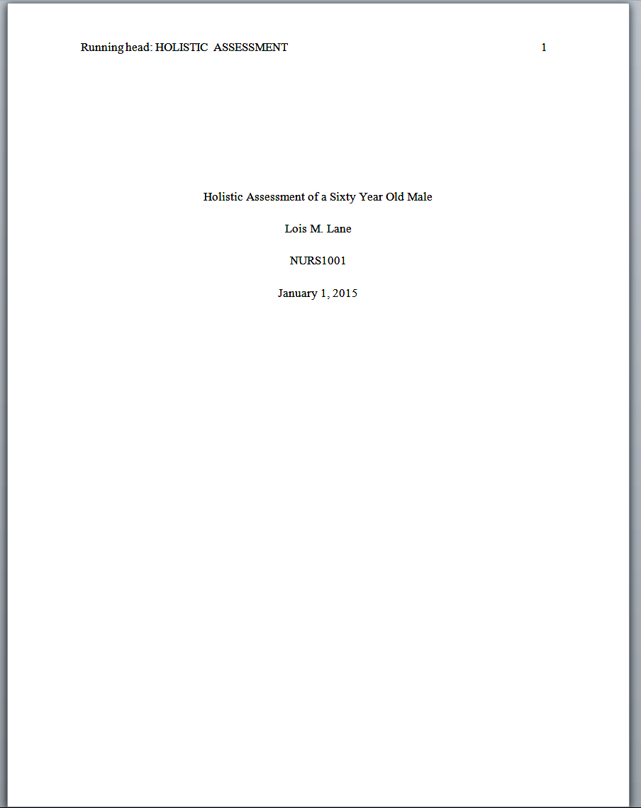
Running head

Notice! This block of text is to be centered in the TOP HALF of the page.

Title Page Layout

Specific word processing instructions will vary according to the software and version that you are using. For detailed instructions access the HELP menu of the word processing program that you are using.

Margins: one inch on all sides

Typeface: New Times Roman, 12 pt.

Running head:

Insert a header, set font to New Times Roman, 12 pt., and enter, on the left margin, the words

Running head:

Notice that the R in running is capitalized and the h in head is not. A colon should immediately follow these words. One space follows the colon and then an abbreviation of your title should appear in ALL CAPS.

Page Number:

The Page Number must appear on the right margin. In order for your page numbers to increment use the features of your word process to INSERT the page number. If you simply type a page number that one number will appear on each page of your document.

Title Block Information:

This block of information is to be centered vertically in the top half of the page. Set alignment to center and enter the following items, double-spaced and on separate lines:

document title
your name
course number
submission date (no abbreviations!)

