ULM SCHOOL of pharmacy

KAppa Epsilon

Family Day T-SHIRTS 2016

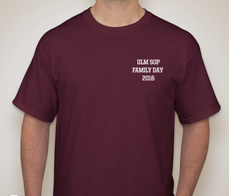
Name:___________________________________________ Classification: _________________
Phone:_____________________________________
E-mail:_________________________________________________

SHORT sleeve $15: S _____ M _____ L _____ XL _____ XXL (+$2) ______ XXXL (+$2) ______
LONG sleeve $20: S _____ M _____ L _____ XL _____ XXL (+$2) ______ XXXL (+$2) ______

Payment Method: Cash or Check # ______ (Circle One) Order Total: _______________

