ACCOUNTHOLDER INSTRUCTIONS

This guide provides information needed for an accountholder to manage transactions. Within this guide, you will learn how to:
- Allocate or edit a transaction and enter a description
- Sign off on a transaction
- Dispute a transaction
- Remove a flag on a transaction
- View Authorization Log
Each of the above topics includes step-by-step instructions for performing a specific task. You can review all of the tasks in this guide or review the task that is specific to your interest.
Allocate or Edit a Transaction and Enter a Description
Procedure:
- On the Home Page under Action Items>Current Status, click on the Pending link.
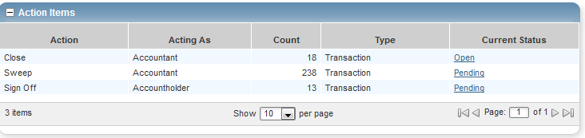
These are the transactions ready for accountholder or approver sign off.
- Click the desired Document number. A menu displays.
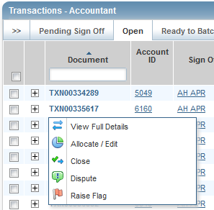

- Select View Full Details. The Transaction Detail screen displays.
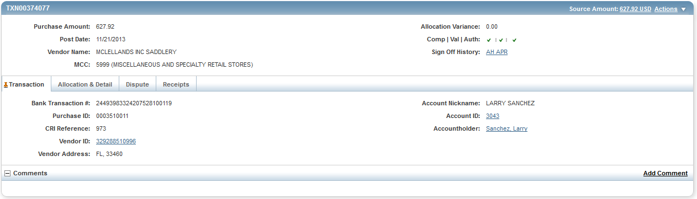
- Select the Allocation & Detail tab.
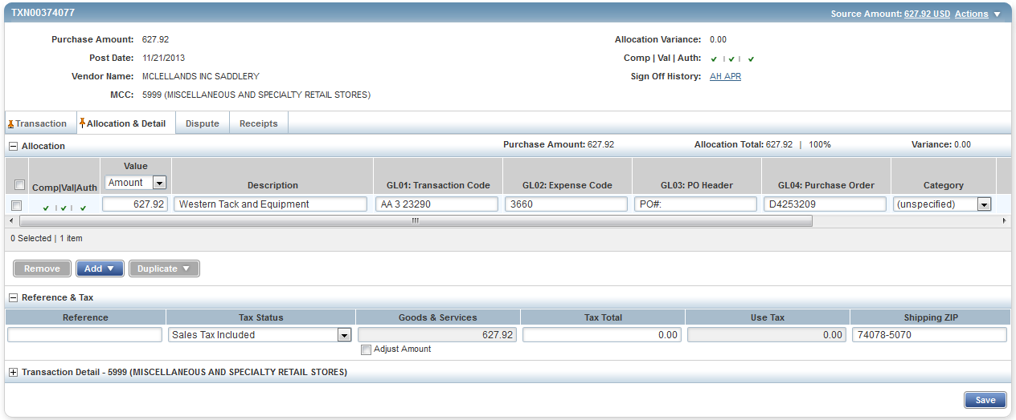
- Select the Allocation & Detail tab, edit, if applicable. Enter codes in the following fields to identify how the segment will be allocated
- GL01: Fund/Agency/Organization
- GL02: Activity
- GL03: Object
- GL04: Sub-Object
- GL05: Agency/Reporting Category

- To add additional lines of funding, click on the Add button and choose how many additional lines you need.
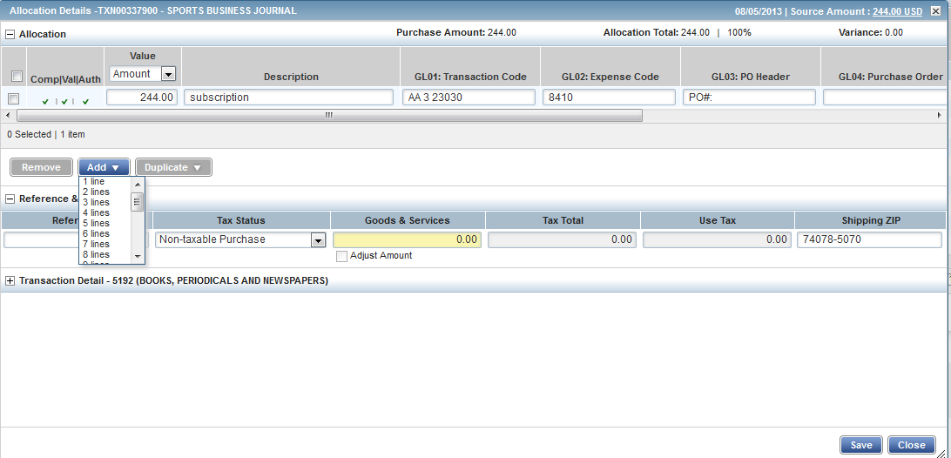
- Fill in the amount, description, account number, and coding for the additional lines of funding.
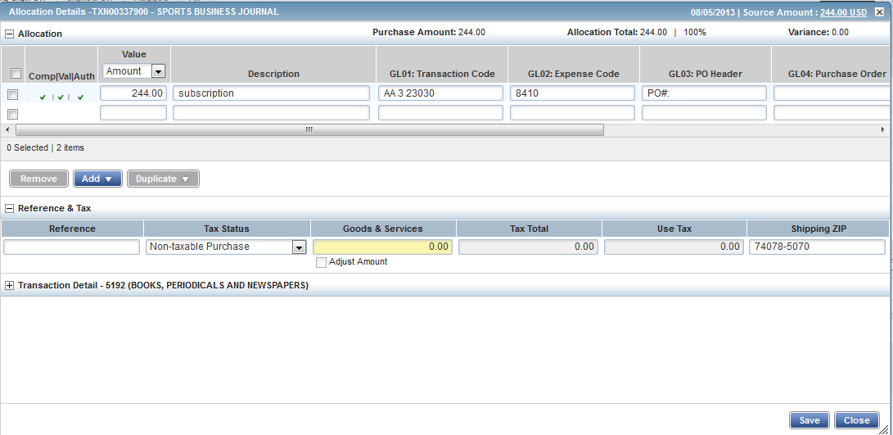
- Click Save.

- In the upper right corner of the Allocation & Detail tab, click on the Actions drop down menu.
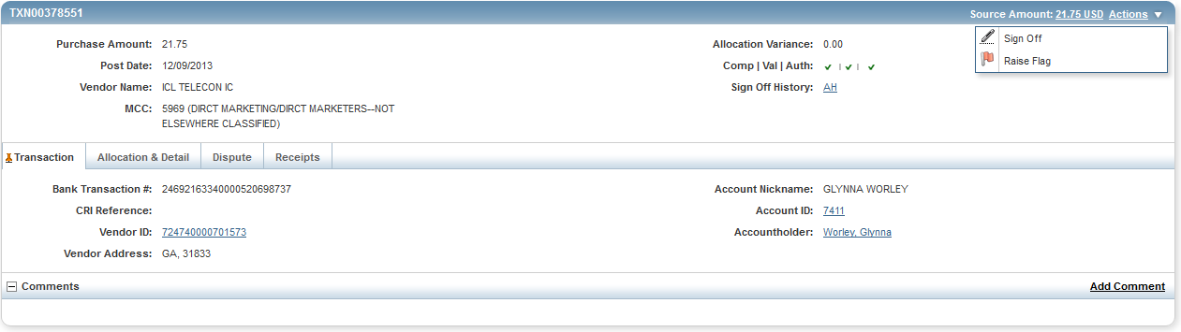

- Click Sign Off. The Confirm Sign Off screen displays enter a description of the transaction.
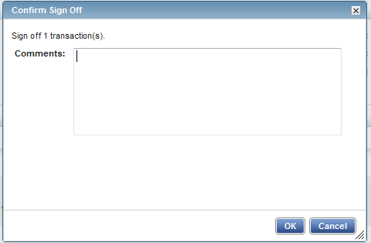

- Click OK.

- This completes the procedure.

Disputing a Transaction

NOTE:
- Accountholders will only be able to dispute their transactions
- Approvers/Managers/Supervisors will only be able to dispute for accountholders they have been assigned to approve, depending on the agency workflow configuration.
- Accountants will be able to dispute Accountholders transaction after the transaction has been swept.

Procedure:

To dispute a transaction, complete the following:

- On the Home Page under Action Items>Sign Off>Current Status, click on the Pending link.
- Click the desired Document number. A drop-down menu displays.
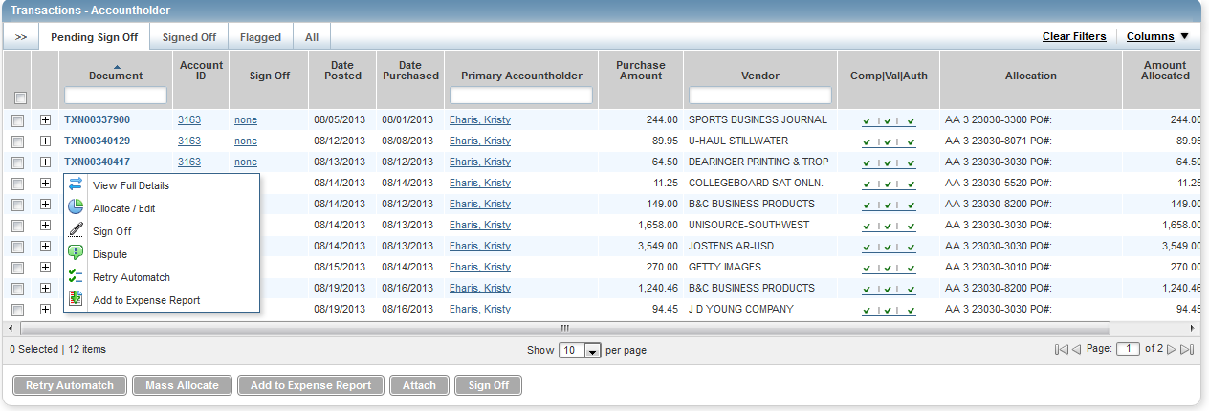

- Click Dispute. The Dispute Transaction screen displays.

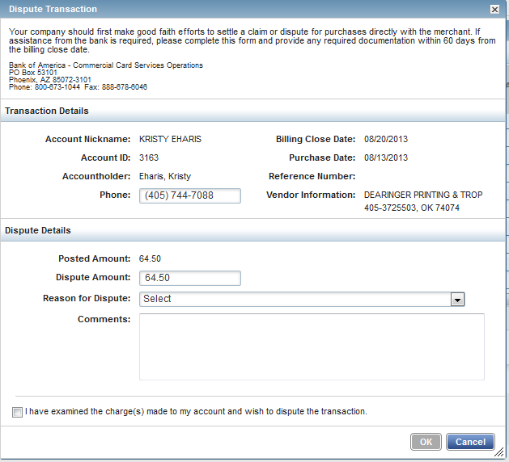

- Enter the Dispute Amount, if different from the purchase total.

- Select the Reason for Dispute from the drop-down menu.
Note: Depending on the Reason for Dispute, additional information may be required.

- Enter Comments, if desired.

- Select the I have examined the charge(s) made to my account and wish to dispute the transaction check box.

- Click OK. The screen displays a confirmation message.

- This completes the procedure.

- NOTE: You must inform your agency LaCarte Program Administrators that you have a dispute

Remove Flag
To remove a flag, complete the following:
- On the Home Page under Action Items>Current Status, click on the Flagged link.

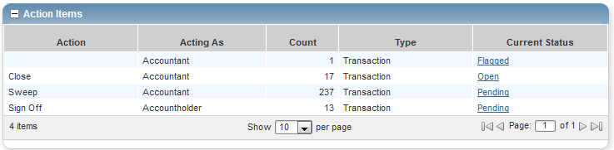

- Select the check box for the Document you wish to “un-flag.” The action buttons at the bottom of the screen become enabled.

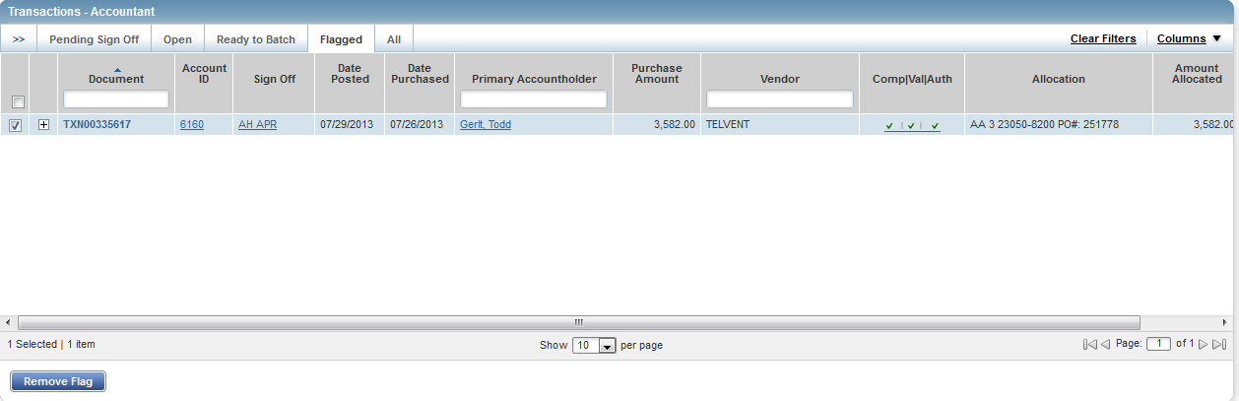

- Click Remove Flag. The Confirm Remove Flag window displays.

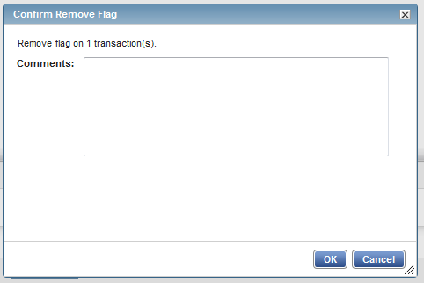

- Enter a Comment. You will not be able to remove the flag unless you enter a comment.

- Click OK.

- This completes the procedure.

VIEW AUTHORIZATION LOG

The Authorization Log allows you to see transactions that have been approved by the bank but have not yet posted to Works; if a transaction was declined, the reason why is shown.

- On the Home Page, Accounts Dashboard, click on the last 4 digits of your account ID.
NOTE: The Accounts Dashboard also lists your credit limit, balance, and available credit. This is useful information easily referenced on the Works Home Page.

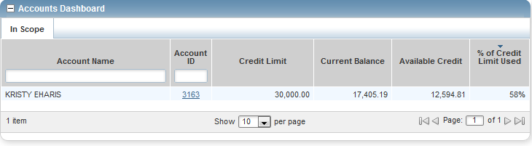

- Click on the Actions link in the upper right corner.

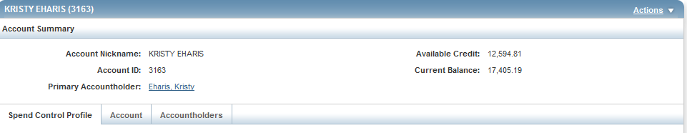

- Click View Auth Log.
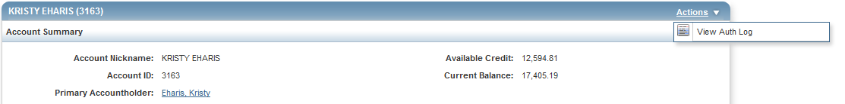

- The next screen will be your Authorization Log.
