Internet Native Banner (INB)
PI Instruction guide to view your grant account

Table of Contents:
1. Steps to log-in
2. Steps to view a summary of your account (FRIGITD)
3. Steps to view all activity in your account (FRIGTRD)
4. Steps to view salary pay detail for all individuals (NHIDIST)

1. Steps to log-in
1. Go to: https://inb.ulm.edu/
2. Click on Production [PROD]
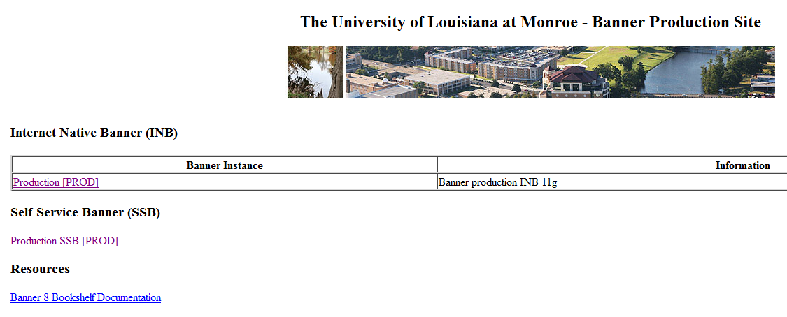
(If a pop-up appears for Java – allow activation)

3. Type in username and password (leave Database blank)
4. Click on connect
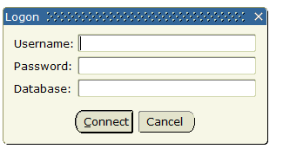

2. Steps to view a summary of your account (FRIGITD)
1. Enter in the Go To…filed FRIGITD and hit your enter key
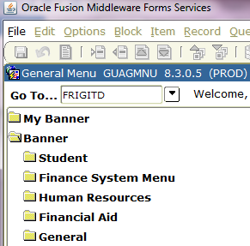

2. Type in your Grant ID code in the Grant: field and Index: and press tab. Or type your fund number in the Fund: field and press your tab key (this will fill in Grant, Org and Program).
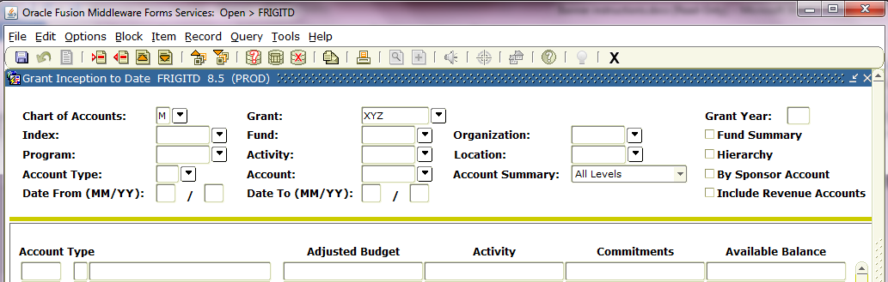

OPTIONAL: You can click on “include revenue accounts” if you want to see the funds that have been received.

3. Then click on Next Block.
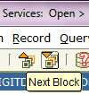

4. Make sure to scroll the bar down – the Net Totals at the bottom will not be correct at the bottom until you scroll to the end
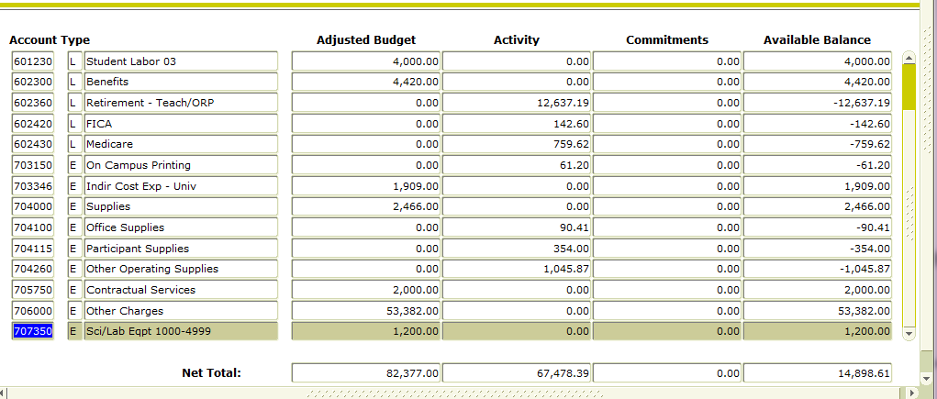
This screen shows the activity of the grant by account (i.e. – different salaries, benefits, travel – in state, out of state, various operating services, supplies, equipment, etc.). It is hard to quickly see which categories are under/overspent, therefore we recommend exporting to excel.

TIP: Deduct the Indirect Cost total from your Available Balance (I.e. $14,898.61 - $1,909 = $12,989.61) if no activity has occurred and in order to get a total of your direct total balance.

OPTIONAL: You can highlight an account, and then click on options in the menu bar, grant detail information. This shows all the individual transactions that make up the total of the account.

OPTIONAL: If you need to view this report for a certain period of time, type in the dates in the “date from” box and “date to” box, then click on next block.

HIGHLY RECOMMENDED: To export any of these screens to an excel spreadsheet, click on Help on the menu bar, then click on Extract Data No Key.
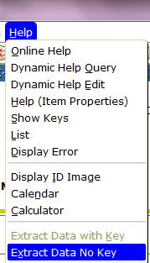
Once in excel, we recommend adding headings, spacing out the categories and adding subtotals.
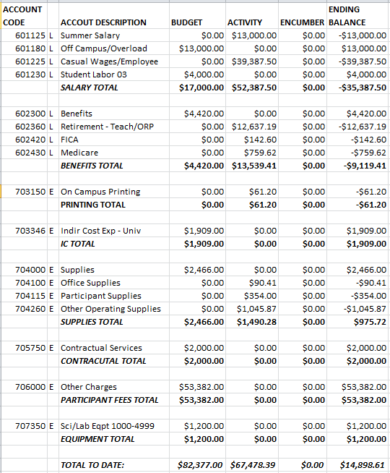

3. Steps to view all activity on your account (FRIGTRD)
1. To go back to the Go To… screen, click the small X on the menu bar.

1. Enter in the Go To…filed FRIGTRD and hit your enter key.
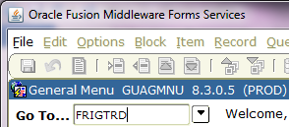

3. Enter your Grant ID in the “Grant” and “Index” fields, then hit tab to populate the other account fields.

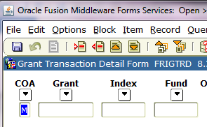

RECOMMENDED: If you proceed with step 4 you will see all transactions, including encumbrance entries, budget entries and actual transactions paid. But if you want to see only the transactions that were actually paid from the grant, in the Field column, in the first block, type in YTD and hit execute query.

4. Click on Next Block and then click Execute Query in the menu bar.
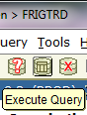

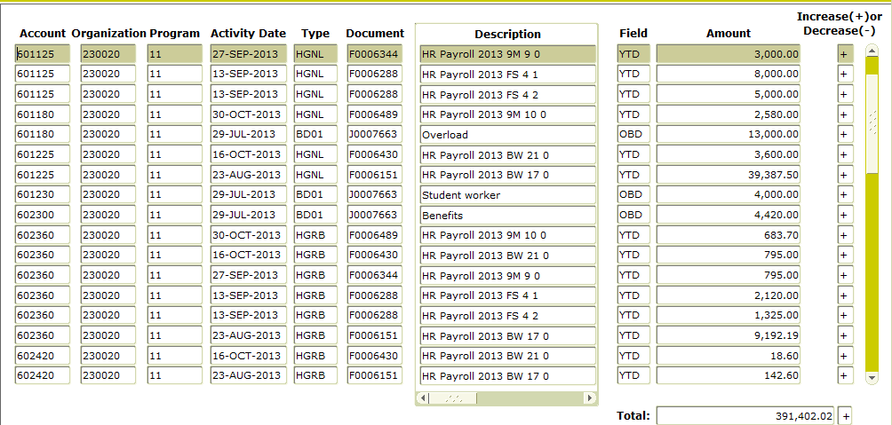
5. Make sure to scroll the bar down – the Net Totals at the bottom will not be correct at the bottom until you scroll to the end
OPTIONAL: As recommended for the FRIGTD screen, this information can also be exported to an excel spreadsheet. Click on Help on the menu bar and then click on Extract Data No Key.
Once in excel, we recommend adding your headings, spacing out the categories and adding subtotals, like in the example above.
Remove the first rows that start with 560210 in column A. (The rows that start in 6XXXXX-personnel pay or 7XXXXX-travel/operating/supplies/equipment are expenses.)
Delete

Remove any rows that list ABD, OBD and ENC in column M. These are not expenses. (Tip: Sort by column M to quickly find all of these entries. To verify you are viewing all of your charges, tally Column N to see if your total expenses match the total you had viewed in the FRIGTRD screen.)
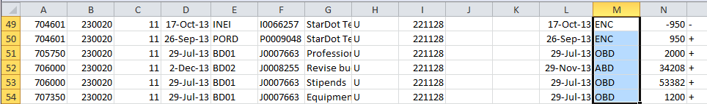
Delete

Tip:
-Column A will tell you what budget category was charged (personnel, travel, operating, supplies, professional services or equipment)
-Column G will provide a description of the vendor or type of expense

-Column L will provide you with the date the expense was charged to the account

-Column N will provide you with the dollar amount charged for the expense.

4. Steps to view salary pay details for all individuals in your account (NHIDIST)
NHIDIST is the Banner Labor Distribution report. This will show you the names of the employees and the amounts paid to each employee and the benefits paid for that employee for the grant. Access to this screen is not automatic. You will have to request access.
1. To go back to the Go To… screen, click the small X on the menu bar.

2. Enter in the Go To…filed NHIDIST and hit your enter key.
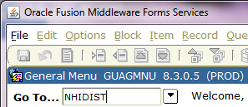

3. Enter your Index: in the field and hit your tab key – this will populate your full account information.
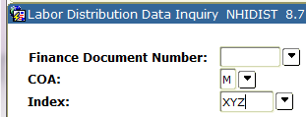

4. Click on Next Block and then click Execute Query in the menu bar.

5. Make sure to scroll the bar down – the Net Totals at the bottom will not be correct at the bottom until you scroll to the end

TIP: If there is a number in the Earnings Code, the Amount is Salary.
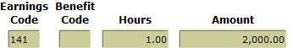

If there is a number in the Benefit Code, the Amount is Benefits.
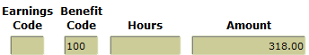

HIGHLY RECOMMENDED: This screen can also be exported to an excel spreadsheet. (If you cannot extract this to an excel spreadsheet, you may need to contact the HELP desk.). Click on Help on the menu bar and then click on Extract Data No Key.

OPTIONAL: If you want to see the employees paid on a certain payroll, type in the finance document number in the box. You can find this number in the detail transaction screen under the “Document” column.

OPTIONAL: If you want to see the employees paid for a certain time period, fill in the “From Date” and the “To Date” and then hit next block, etc.

