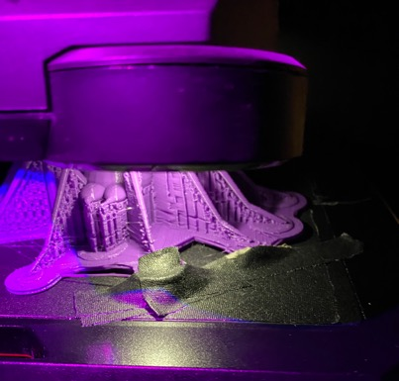
Hannah Branson 3D Print with pla material 2. 25”H x 6”W x 6”D 2020

