ULM BOOKING GUIDE
STEP 1
- Go to your intranet booking site & select your department

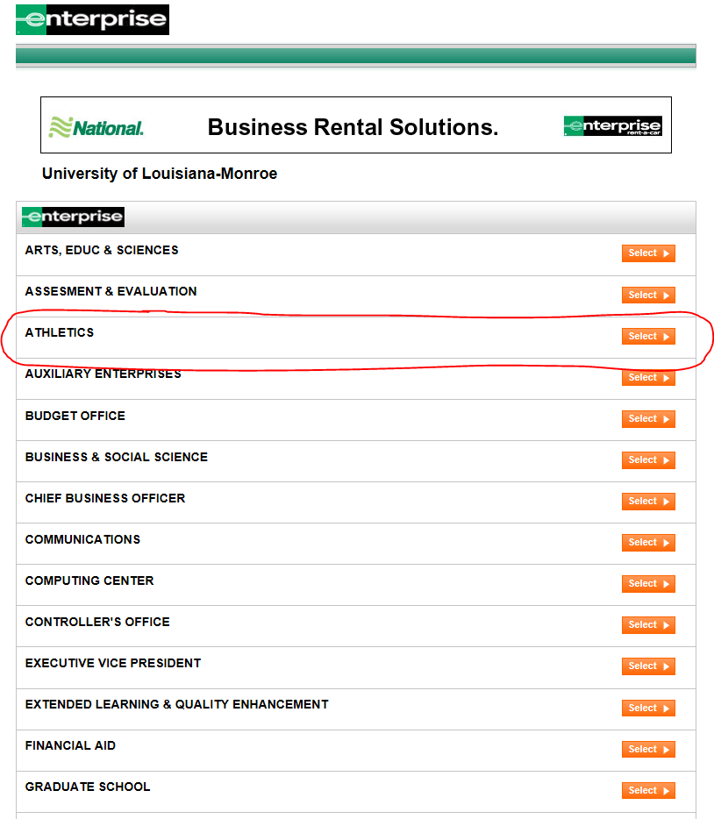

STEP 2
- Select your location, dates & times
- If you are an EPLUS or Emerald Club member you can log in

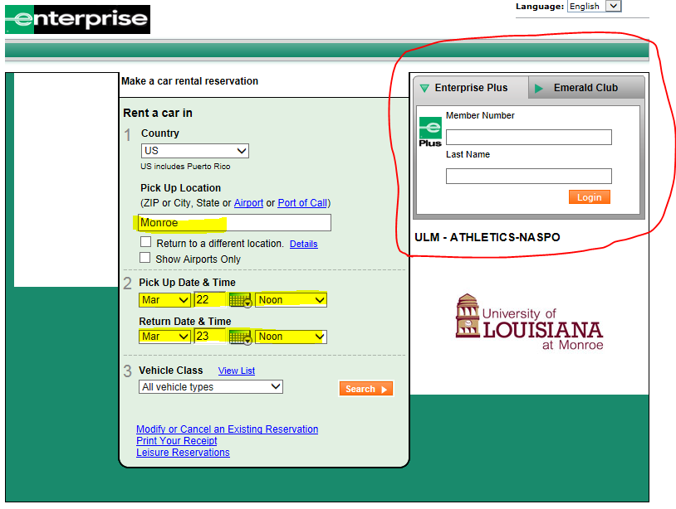

STEP 3
- If multiple locations you can select the one most convenient

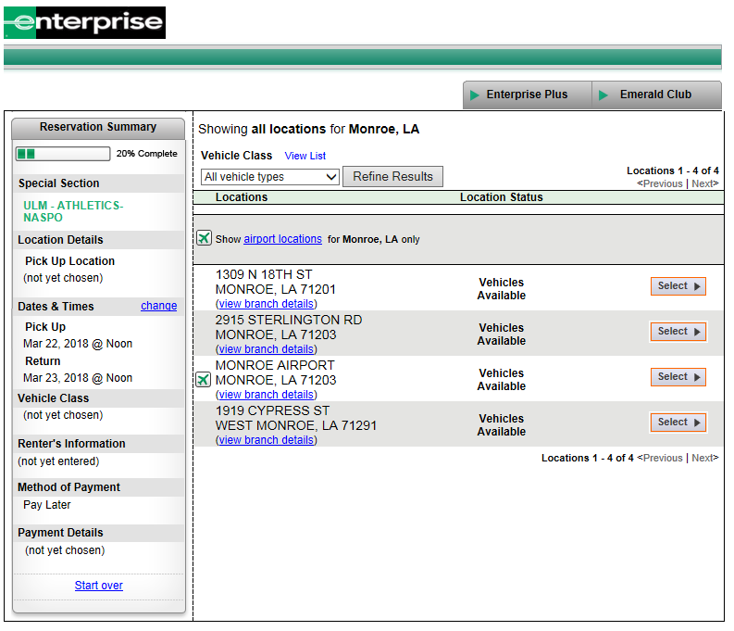

STEP 4
- Choose your vehicle
  - The total price will always include taxes. We remove the taxes when we write the ticket because you are tax exempt, but do pay for VLF.

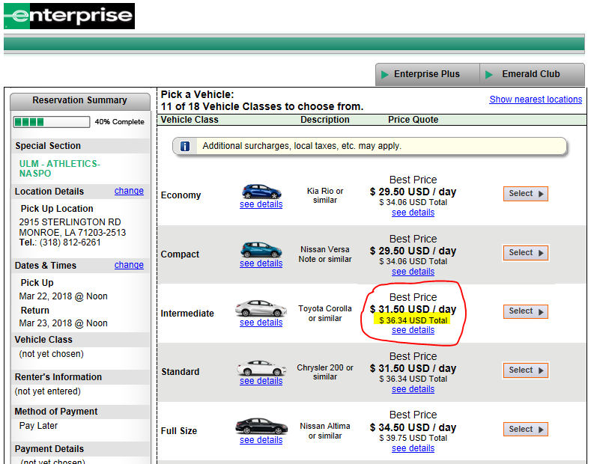

STEP 5
- Main Information
  - Please fill out and use a cell phone number
- Corporate Account Details
  - Once you select yes in the first billing field the bottom two will open up. You will enter your 8 digit billing number that is specific to your department.
- Get your rental started
  - If you are not an EPLUS member the more your fill out will save you time at the branch
- Additional Information
  - If you fly anywhere please put this information in. We monitor flight changes and if that is in there we will know what time you are landing.
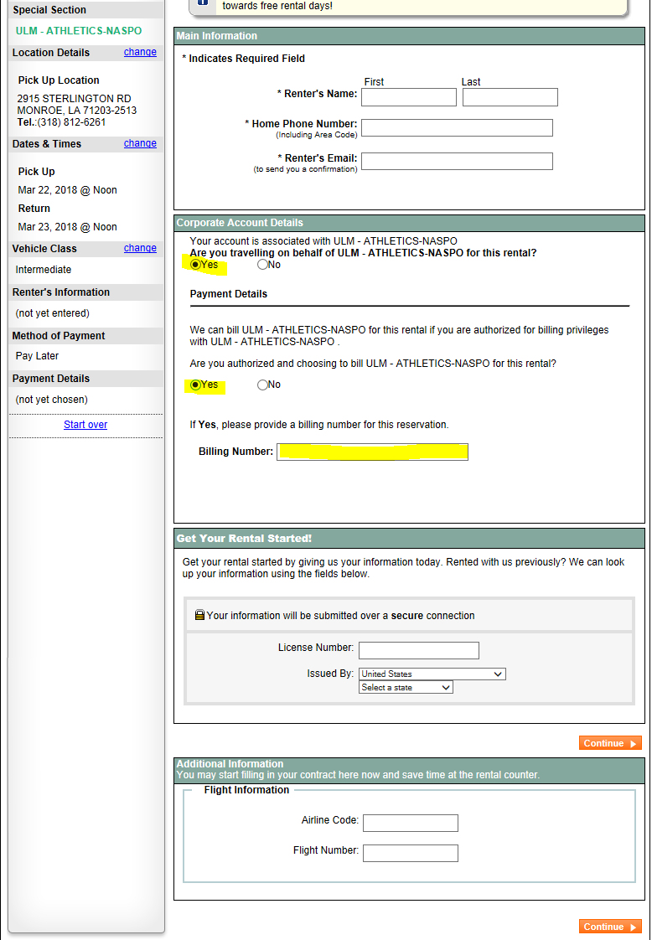

STEP 6
- Summary of charges. Reminder the taxes will be removed. The bottom left corner verifies that the rental is being billed to ULM – Athletics.
- Select Book now to complete your reservation

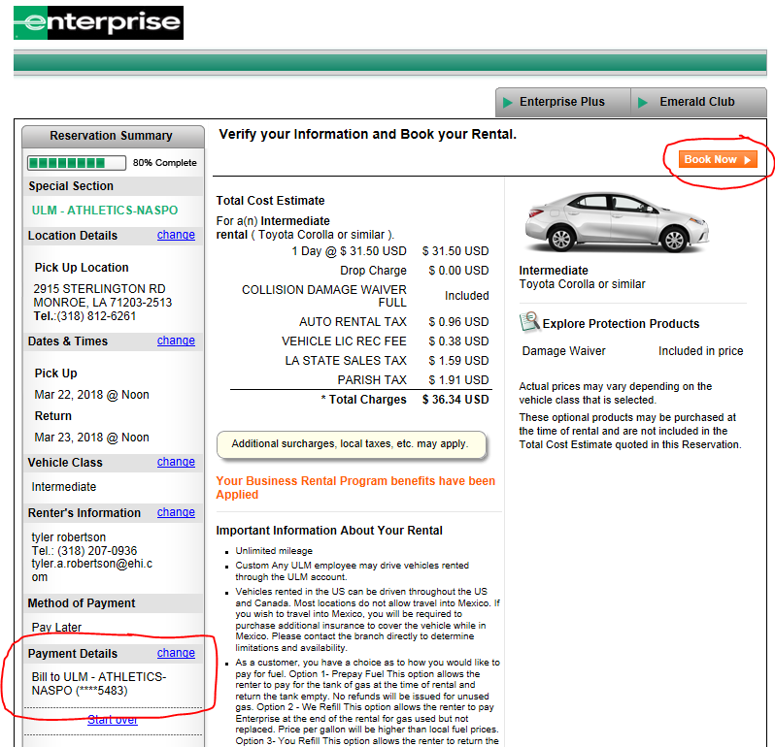

STEP 7
- Get your confirmation code & it also shows that a billing number has been applied to this reservation

