University of Louisiana Monroe

Counseling Program 2024-25 Annual Review

Introduction

The University of Louisiana at Monroe (ULM) Counseling Program is part of the School of Allied Health within the College of Health Sciences. The program offers Master of Science in two 60-credit-hour concentrations: Clinical Mental Health Counseling and School Counseling. Both program concentrations are accredited by the Council for Accreditation of Counseling and Related Educational Programs (CACREP). This year, the program has begun the process of transferring to the 2024 CACREP standards for each concentration. Our last CACREP re-accreditation was in 2020, and this summary is specific to the Mid-Cycle Report for 2024.

Current Accreditation Information

ULM’s Counseling Program currently has two CACREP accredited specialty areas in Clinical Mental Health Counseling and School Counseling. Both specialty areas are accredited under the 2016 CACREP standards. They are each 60 credit programs. All of the curriculum in both specialty areas is offered in an online format.

Changes and Maintenances in Program Operations

Curriculum. The Counseling Program at ULM has undergone some minor changes in the 2024-25 academic year. First, we made some curriculum changes to the program by adding some new elective courses that will be reflected in the 2026-27 Graduate Catalog. These courses are: (a) Telehealth Counseling, (b) A.I. in Counseling, and (c) Psychosocial Aspects of Disability. In addition, the Counseling faculty unanimously decided to end the Addiction Counseling concentration, the Marriage, Couple, and Family (MCFC) concentration, and all combined track options. The program will keep its accredited Clinical Mental Health Counseling and School Counseling concentrations. The courses developed for the Addiction and MCFC concentrations will be kept on as electives.

Students. For the 2024 fall cohort, the Counseling Program has maintained the number of incoming students at 75. This is the second year in a row the program has been able to bring in that number. In 2020 and 2021, the program accepted 30 students into each cohort. For the Fall 2022 cohort, the program accepted 60 students, and for the Fall 2023 cohort the program accepted 75 students into the program. This demonstrates steady growth for the program over the last five years.

Faculty. For the 2024-25 academic year, the Counseling Program hired Deborah Grant (Debbie) and Morgan Wallbrown (Mo) as our seventh and eighth faculty members. In addition, the Counseling Program had a 100% faculty retention rate this year. This is notable because this is the first time the program had a 100% faculty retention rate in at least seven years, which indicates program stability is increasing. Below is a table that lists full time faculty and if they are core or non-core, their specialty areas, and administrative duties.
CACREP. For the last year, Drs. Foster and Moon have been preparing the program to begin writing the CACREP self-study for the 2025-26 year. They have been working with a consultant (Dr. Kelly Coker) to get the program in compliance with the new 2024 CACREP standards.

In October of 2024, the Counseling Program sent in their response letter to CACREP addressing how they are now meeting the two standards in which they were deficient. In March of 2025 CACREP responded to the letter indicating that the program has indeed met the standards and granted accreditation until March of 2028.

In October of 2024, the Counseling Program submitted their mid-cycle report to CACREP. The mid-cycle report is a snapshot of how the program is going and how they are meeting specific standards. One standard addressed in the report is the FTE faculty/student ratios, which are set at a maximum of 12 students to 1 faculty. In the spring of 2024, the ratio was 13:1, exceeding the standard. CACREP’s response to the mid-cycle report was for the program to follow up with an additional report due in November of 2025 indicating what the faculty to student ratios are for the semesters of Fall 24, Spring 25, and Summer 25. At this time, the ratios for these semesters are all at or below 12 to 1, indicating we are in compliance (see below).

Full-Time Faculty

Faculty | Core/Noncore | Specialty | Administrative Duties
Dr. Thomas Foster | Core | CMHC | Program Director
Dr. Poppy Moon | Core | School | P&I Coordinator  School Counseling Coordinator  Comps Coordinator
Dr. Tonya Elliott | Core | CMHC | MCFC Coordinator
Dr. Ruoxi Chen | Non-Core | MFT | MCFC Coordinator
Dr. Deborah Grant | Core | CMHC, Addiction, School | Addictions Coordinator, Summer Workshop Coordinator
Dr. Michelle Dobson | Core | CMHC
Dr. Yolanda Dupre | Core | CMHC, School
Dr. Morgan Wallbrown | Core | CMHC

Faculty to Student Ratios Return to Top
Semester/Year | Total SCH | Average Credit Hours Taken | Faculty FTE | Faculty to Student Ratio
Fall 2024 | 1,467 | 12 | 10.64 | 11 to 1
Spring 2025 | 1,476 | 12 | 10 | 12 to 1
Summer 2025 | 627 | 6 | 9.98 | 10 to 1

Revised Program Mission, Purpose, and Commitment to Diversity Statement

For the 2024-25 academic year, the Counseling Program revised its mission, purpose, and commitment to diversity statement at two points in time. The first time, the Counseling faculty made revisions in the fall of 2024 at their program identity meeting. These revisions were all agreed upon by the faculty and sent out for feedback from the students and Counseling Advisory Committee.
The second time revisions were made late in the spring 2025 semester. The College mandated all programs in the College of Health Sciences to scrub all DEI-related language from their websites and starting in the fall of 2025 to officially change the names of any courses that contain DEI-related language. Changes to the website material led to changes in the mission, purpose, and commitment to diversity statement. These changes were initially made by just a couple faculty due to the urgency of the college mandate but will be addressed fully by all Counseling faculty in the fall of 2025. Click here to review the mission, purpose, goal, and objectives for the revised edition for the 2024-25 year, they are taken from the program website.

Continuing with Last Year’s Program Objectives, KPIs, and Skills/Disposition Assessment Procedures

This year the counseling faculty continued with the program standards developed in 2023 that addresses the 2024 CACREP standards. The program objectives are found in required core courses and evaluated using assignments in these classes (also known as Key Performance Indicators [KPI]). In accordance with CACREP, these KPIs are evaluated at least two times during a student’s time in the program; the first KPI for core and specialty areas is within content courses (e.g., Intro to Professional Counseling, Theories of Counseling, Career Counseling) and the second KPI for core and specialty areas are in fieldwork courses (i.e. Practicum, School Practicum, Internship, School Internship). We set the minimal threshold score for the content KPIs at 70%, which is the same as a passing score for the counseling classes at ULM. We set the skills and professional disposition minimal threshold score at 80% due to their overall importance for students to possess and be successful clinicians.

Scoring and storing the KPIs for knowledge and skill are done in Tevera. Rubrics for each KPI are provided and are on a 5-point Likert scale (5=Advanced; 4=Proficient; 3=Basic; 2=Developing; 1=Deficient) that measures student performance on specific core and specialty standards. Each Likert score is converted to a percentage to determine if they met the 70% or 80% threshold. (i.e., 5=100%; 4=90%; 3=80%; 2=70%; 1=60%). Individual scores are calculated by converting the Likert score to the percentage, adding each item score together, and dividing by how many items were scored thus giving an average subscore for the assessment. Any subscore under the 70% or 80% threshold (depending on the KPI) will not meet the minimal threshold.

Student Performance for 2024-25

Faculty met during the fall, spring, and summer semesters of 2024-25 to discuss each student in the program in terms of their KPI scores, clinical and professional disposition scores of the CCS-R, and overall performance. Students of concern were discussed and any formal or informal remediation plans in place were reviewed. Overall KPI scores and clinical/disposition scores of the CCS-R are provided below and can be found at the links below. The mean, minimum and maximum scores, and standard deviation are provided.

- Fall 2024 Courses KPI scores for First- and Second-Year Classes
- Fall 2024 Clinical Course CSS-R Results
- Spring 2025 Courses KPI scores for First- and Second-Year Classes
- Spring 2025 Clinical Course CSS-R Results
- Summer 2025 Course KPI Scores
- Summer 2025 Clinical Course CCS-R Results

Fall 2024 didactic courses. First and second year fall didactic courses are divided up and listed by cohort . Results indicate that all students in the first-year fall courses scored above the 70% minimal threshold for the program objectives. Results indicate that all students in the second-year fall courses scored above the 70% minimal threshold for the program objectives.

Fall 2024 clinical courses. The CCS-R is used to assess for clinical skills and professional disposition in the Practicum, Internship, and School Internship courses. Each student is assessed using the CCS-R during the midterm and final by their faculty supervisor and site supervisor. Students also evaluate themselves using the CCS-R at the end of the semester. Last, students evaluate their site and site supervisor at the end of the semester. All the results for students in the fall clinical courses (i.e., Practicum, Internship, School Internship) all scored above the 80% minimal threshold, requiring no need for remediation.

Spring 2025 didactic courses. First and second year spring didactic courses are divided up and listed by cohort. Results indicate that all students in the first and second-year spring courses scored above the 70% minimal threshold for the program objectives.

Spring 2025 clinical courses. The CCS-R is used to assess for clinical skills and professional disposition in the Practicum, Internship, and School Internship courses. Each student is assessed using the CCS-R during the midterm and final by their faculty supervisor and site supervisor. All the results for the students in the spring clinical courses (i.e., Internship, School Internship) all scored above the 80% minimal threshold, requiring no need for remediation.

Summer 2025 didactic courses. There was only one didactic course that had a KPI. Results indicate that all students in the summer course scored above the 70% minimal threshold for the program objectives.

Summer 2025 clinical courses. The CCS-R is used to assess for clinical skills and professional disposition in the Practicum and Internship courses. Each student is assessed using the CCS-R during the midterm and final by their faculty supervisor and site supervisor. All the results for the students in the spring clinical courses (i.e., Practicum and Internship) all scored above the 80% minimal threshold for faculty supervisors, requiring no need for remediation. One student scored under 80% by the site supervisor, but it was not reported in time to remediate.

Trend Analysis in Practicum and Internship

Trend analysis is a statistical and analytical technique used to evaluate and identify patterns, trends, or changes in data over time. We use trend analysis in the Practicum, Internship, and School Internship to look for changes in student clinical skills and professional disposition over the course of a semester. Faculty and site supervisors evaluate students on these clinical skills and professional disposition using the CCS-R at the midterm and end of each semester.

Starting in the spring of 2025, we used a dependent one-tailed t-test to determine if there were significant differences between midterm and final evaluations within courses on the CCS-R for clinical skills and professional dispositions in the Practicum, Internship, and School Internship courses each semester. Results are below.

Spring 2025. Results of the trend analysis for the spring 2025 indicate the following for each class. For Internship, there was a significant difference between midterm and final evaluations on the CCR-S for clinical skills and professional disposition for faculty and site supervisor evaluations (see results here), indicating clinical skills and disposition performance improved in students.

For School Internship, there was a significant difference between midterm and final evaluations on the CCR-S for clinical skills and professional disposition for faculty and site supervisor evaluations (see results here), indicating clinical skills and disposition performance improved in students.

Summer 2025. Results of the trend analysis for summer 2025 indicate the following for each class. For Practicum, there was a significant difference between midterm and final evaluations on the CCR-S for clinical skills and professional disposition for faculty supervisors (see results here), indicating clinical skills and disposition performance improved in students. However, there was no significant difference between midterm and final evaluations on the CCR-S for clinical skills and professional disposition for site supervisors. However, means scores of the midterm and final evaluations find that final evaluation mean scores are higher than midterm scores, suggesting that performance in clinical skills and disposition did trend upward.

For Internship, there was a significant difference between midterm and final evaluations on the CCR-S for clinical skills for faculty supervisors (see results here), indicating clinical skill performance improved in students. However, there was no significant difference between midterm and final evaluations on the CCR-S for professional disposition for faculty supervisors. Although, mean scores for disposition on the midterm and final evaluations find that final evaluation mean scores are higher than midterm scores, suggesting that performance in disposition did trend upward.

There was no significant difference between midterm and final scores for site supervisor evaluations, even though the mean final scores were higher than the midterm scores thus suggesting a trend upward.

Student self-evaluation. At the end of each semester students self-evaluate themselves on their clinical skills and professional disposition using the CCS-R. Results of the Fall 2024, Spring 2025, and Summer 2025 semesters indicate students rated themselves very high on their clinical skills and professional dispositions. Click here to review the results.

Student evaluation of site and supervisor. At the end of each semester students evaluate their site and site supervisor using a survey developed by faculty and provided in Tevera. Total scores can range from 0 to 100. Results indicate that Practicum students, Internship students, and school counseling students are very satisfied with their site and site supervisor for the fall and spring semesters this year. Click here to review the results.

Program Evaluation and Improvements 2024-25

Every year, throughout the year, the Counseling Program collects data from a variety of sources to make improvements to the program: current student survey, summer workshop survey, graduating student survey, supervisor survey, alumni survey, employer survey, and Counseling Advisory Committee (CAC). Based on the feedback given, this year the majority of the feedback that was used to make improvements came from the current student feedback and course evaluations. This feedback is below. The data reported on below was collected during the 2024-25 year.

CMHC feedback. The survey for current students had themes related to elective availability throughout the year. Specifically, students reported there were not enough elective sections to accommodate everyone. Therefore, the faculty agreed to open additional sections of electives throughout the year starting in fall 2025. In addition, if faculty were not able to teach their created elective course, they would give the course shell to an adjunct to teach. In fall 2025, the program opened an additional section of COUN 6060 Intro to Marriage, Couple, and Family Counseling, and opened a section of COUN 6040 Trauma Counseling. Trauma Counseling is typically taught by a core faculty, but since they were not able to teach it in the fall their Canvas course shell was given to an adjunct to teach.
Students provided much feedback within the new course evaluations the Counseling Program puts out at the end of each semester. Faculty review their individual feedback and make needed changes to their classes. Due to the idiosyncrasy of the feedback and changes made, we are just reporting here that it is happening.

School counseling feedback. Due to the many changes made to the school counseling concentration in the recent years, there has not been much feedback from students or CAC about this. Much of the feedback was the same as the CMHC regarding electives and specific course feedback.

Counseling Program’s Mission, Purpose, Goal, and Objectives Return to Top
______________________________________________________________________________

Our Mission and Purpose

Rooted in ethical competency and evidence-based practices, our Counselor Education program cultivates compassionate, respectful professionals who understand the complexities of human growth across the lifespan. Our program prepares future counselors to navigate lifespan issues with a reflective and dynamic approach. By emphasizing ethical practices, self-reflection, and a variety of counseling techniques, we empower students to become lifelong learners and skilled professionals, ready to serve and make meaningful connections in distinctive and evolving communities.

Our purpose is to work with students from all over the world and contribute solutions to the growing global need of mental health and school services for everyone.

Our Primary Goal

The Counseling faculty prepare skilled practitioners with a Professional Counseling identity through a program of planned, sequenced, and educational experiences that address the following objectives.

Program Objectives / CACREP Key Performance Indicators

The Counseling faculty created the following program objectives / key performance indicators for students in the Counseling Program and demonstrate how they relate to the 2024 CACREP Core Standards.

- Students will develop a professional identity as a counselor related to their concentration that will be measured at two points in time with a success rate at or above 70%.
  - CACREP Core 3.A. Professional Counseling Orientation and Ethical Practice

- Students will apply ethical practices and principles in the practice of counseling related to their concentration that will be measured at two points in time with a success rate at or above 70%.
  - CACREP Core 3.A. Professional Counseling Orientation and Ethical Practice

- Students will apply the social identities competencies in the practice of counseling related to their concentration that will be measured at two points in time with a success rate at or above 70%.
  - CACREP Core 3.B. Social Identities and Experiences

- Students will learn assessment content and skills in the practice of counseling related to their concentration that will be measured at two points in time with a success rate at or above 70%.
  - CACREP Core 3.G. Assessment and Diagnostic Processes

- Students will learn diagnostic content and skills in the practice of counseling related to their concentration that will be measured at two points in time with a success rate at or above 70%.
  - CACREP Core 3.G. Assessment and Diagnostic Processes

- Students will learn counseling theoretical approaches related to their concentration that will be measured at two points in time with a success rate at or above 70%.
  - CACREP Core 3.E. Counseling Practice and Relationships

- Students will learn counseling developmental approaches related to their concentration that will be measured at two points in time with a success rate at or above 70%.
  - CACREP Core 3.C. Lifespan Development

- Students will learn career counseling theories and approaches related to their concentration that will be measured at two points in time with a success rate at or above 70%.
  - CACREP Core 3.D. Career Development

- Students will learn research skills and strategies related to their concentration that will be measured at two points in time with a success rate at or above 70%.
  - CACREP Core 3.H. Research and Program Evaluation

- Students will learn individual clinical skills and strategies in the practice of counseling related to their concentration that will be measured at two points in time with a success rate at or above 80%.
  - CACREP Core 3.E. Counseling Practice and Relationships

- Students will learn group skills and strategies in the practice of counseling related to their concentration that will be measured at two points in time with a success rate at or above 80%.
  - CACREP Core 3.F. Group Counseling and Group Work

- Students will demonstrate skills in the practice of counseling related to their concentration that will be measured at six points in time using the Counselors Competency Scale - Revised with a success rate at or above 80%.
  - CACREP Core 3.E. Counseling Practice and Relationships

- Students will demonstrate professional dispositions in the practice of counseling related to their concentration that will be measured at six points in time using the Counselors Competency Scale - Revised with a success rate at or above 80%.
  - CACREP Core 2.C.2.a.b.c. Individual Student Assessment

Clinical Mental Health Counseling Concentration

- Students will demonstrate content knowledge related to the Clinical Mental Health Counseling concentration that will be measured at two points in time with a success rateof 70% or higher.
  - CACREP Section 5.C. Clinical Mental Health Counseling

- Students will demonstrate skills in the practice of counseling related to the Clinical Mental Health Counseling concentration that will be measured at six points in time using the Counselors Competency Scale - Revised with a success rate at or above 80%.
  - CACREP Section 5.C. Clinical Mental Health Counseling

- Students will demonstrate professional dispositions in the practice of counseling related to the Clinical Mental Health Counseling concentration that will be measured at six points in time using the Counselors Competency Scale - Revised with a success rate at or above 80%.

  - CACREP Section 5.C. Clinical Mental Health Counseling

School Counseling Concentration

- Students will demonstrate content knowledge related to the School Counseling concentration that will be measured at two points in time with a success rateof 70% or higher.
  - CACREP Section 5.H. School Counseling

- Students will demonstrate skills in the practice of counseling related to the School Counseling concentration that will be measured at six points in time using the Counselors Competency Scale - Revised with a success rate at or above 80%.
  - CACREP Section 5.H. School Counseling

- Students will demonstrate professional dispositions in the practice of counseling related to the School Counseling concentration that will be measured at six points in time using the Counselors Competency Scale - Revised with a success rate at or above 80%.

  - CACREP Section 5.H. School Counseling

Our Commitment to Student Success

The Counseling Program at ULM is committed to advancing and advocating for all students who are admitted to the program. We consider and invite a variety of applicants into the Counseling Program each year and attempt to foster and maintain a safe environment of respect and acceptance for faculty, staff, students, and members of the communities we serve.
We educate and encourage our students to support the ones they work with as clinical mental health and school counselors through our curriculum and clinical experiences that reflects and values respect for all persons.
______________________________________________________________________________

First Year KPI#1 and CCS-R Results Return to Top
______________________________________________________________________________

Fall 2024 KPI#1 and CCS-R First and Second Year Students

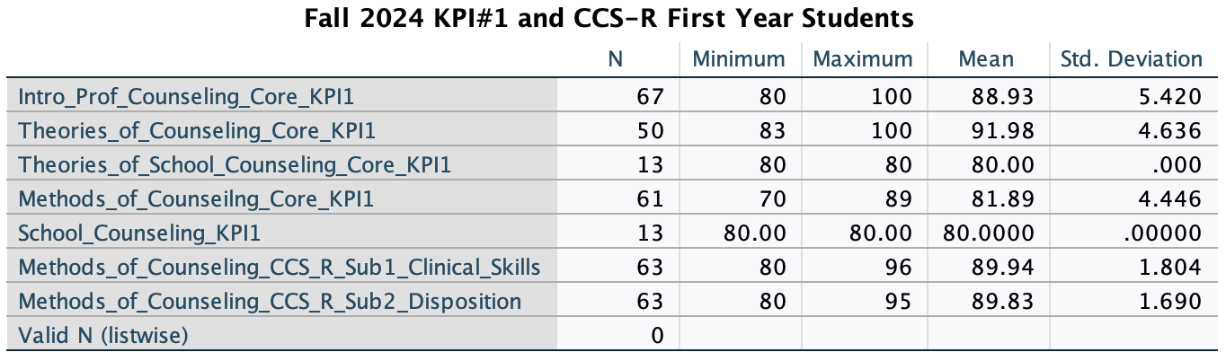
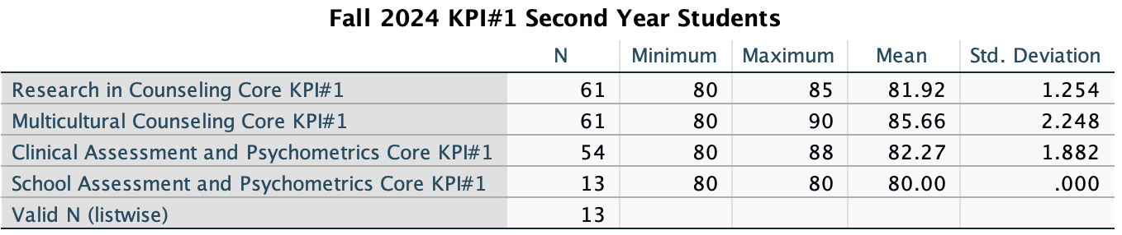

Spring 2025 KPI#1 and CCS-R First and Second Year Students

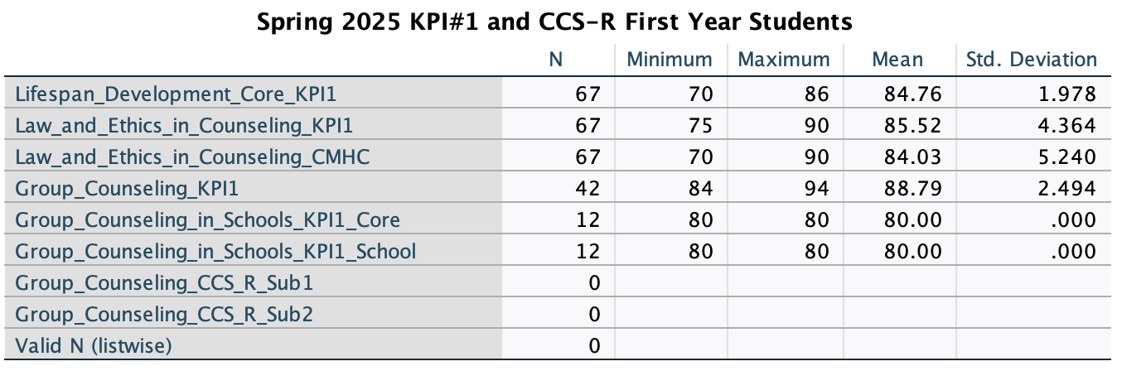
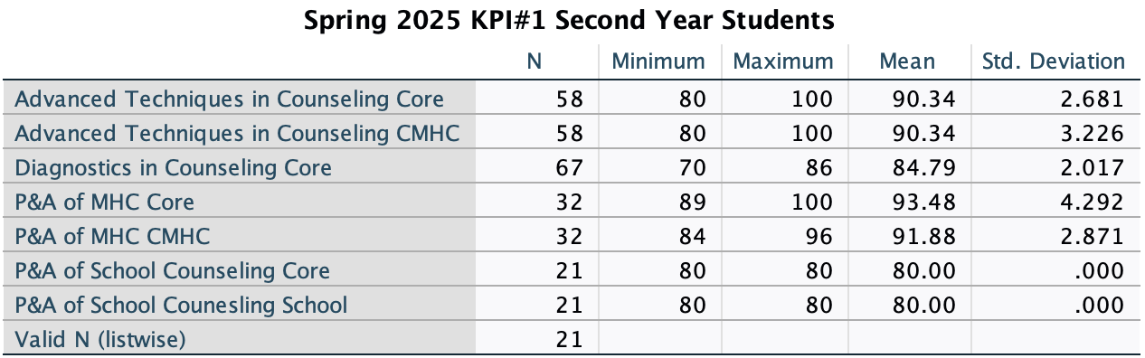

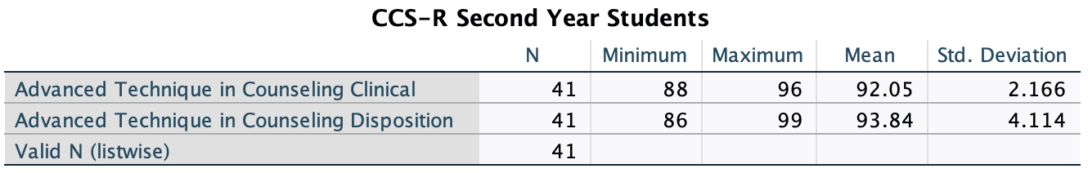

Summer 2025 KPI#1 First Year Students Return to Top

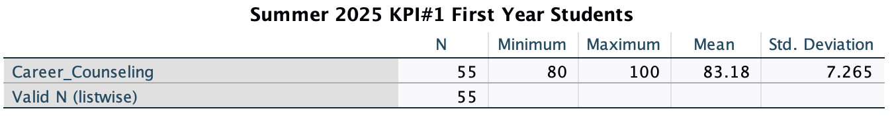

Fall 2024 COUN 5065: Practicum CSS-R Results Return to Top

Faculty Supervisor Evaluations Midterm
 | N | Min | Max | Mean | Std. Deviation
Clinical Skills | 1 | 100 | 100 | 100 | -
Disposition | 1 | 100 | 100 | 100 | -

Faculty Supervisor Evaluations Final
 | N | Min | Max | Mean | Std. Deviation
Clinical Skills | 1 | 100 | 100 | 100 | -
Disposition | 1 | 100 | 100 | 100 | -

Site Supervisor Evaluations Midterm
 | N | Min | Max | Mean | Std. Deviation
Clinical Skills | 1 | 100 | 100 | 100 | -
Disposition | 1 | 100 | 100 | 100 | -

Site Supervisor Evaluations Final
 | N | Min | Max | Mean | Std. Deviation
Clinical Skills | 1 | 100 | 100 | 100 | -
Disposition | 1 | 100 | 100 | 100 | -

Fall 2024 COUN 6070: Internship CSS-R Results Return to Top

Faculty Supervisor Evaluations Midterm
 | N | Min | Max | Mean | Std. Deviation
Clinical Skills | 21 | 90 | 100 | 95 | 4.56
Disposition | 21 | 90 | 100 | 95 | 4.85

Faculty Supervisor Evaluations Final
 | N | Min | Max | Mean | Std. Deviation
Clinical Skills | 22 | 90 | 100 | 95 | 5.03
Disposition | 22 | 90 | 100 | 95 | 5.09

Site Supervisor Evaluations Midterm
 | N | Min | Max | Mean | Std. Deviation
Clinical Skills | 20 | 78 | 100 | 93 | 5.69
Disposition | 20 | 85 | 100 | 95 | 4.56

Site Supervisor Evaluations Final
 | N | Min | Max | Mean | Std. Deviation
Clinical Skills | 18 | 83 | 100 | 96 | 4.63
Disposition | 18 | 85 | 100 | 96 | 4.17

Fall 2024 COUN 6071: School Internship CSS-R Results Return to Top

Faculty Supervisor Evaluations Midterm
 | N | Min | Max | Mean | Std. Deviation
Clinical Skills | 6 | 90 | 92 | 91 | .87
Disposition | 6 | 89 | 91 | 90 | 1.14

Faculty Supervisor Evaluations Final
 | N | Min | Max | Mean | Std. Deviation
Clinical Skills | 6 | 89 | 90 | 90 | .92
Disposition | 6 | 90 | 90 | 90 | -

Site Supervisor Evaluations Midterm
 | N | Min | Max | Mean | Std. Deviation
Clinical Skills | 4 | 90 | 100 | 95 | 4.30
Disposition | 4 | 89 | 100 | 95 | 5.08

Site Supervisor Evaluations Final
 | N | Min | Max | Mean | Std. Deviation
Clinical Skills | 5 | 93 | 100 | 96 | 2.84
Disposition | 5 | 96 | 100 | 98 | 1.34

Spring 2025 COUN 5065: Practicum CSS-R Results Return to Top

No Practicum in the spring.

Spring 2025 COUN 6070: Internship CSS-R Results Return to Top

Faculty Supervisor Evaluations Midterm
 | N | Min | Max | Mean | Std. Deviation
Clinical Skills | 21 | 85 | 100 | 95 | 6.22
Disposition | 21 | 86 | 100 | 96 | 5.61

Faculty Supervisor Evaluations Final
 | N | Min | Max | Mean | Std. Deviation
Clinical Skills | 23 | 95 | 100 | 99 | 1.34
Disposition | 23 | 97 | 100 | 99 | .75

Site Supervisor Evaluations Midterm
 | N | Min | Max | Mean | Std. Deviation
Clinical Skills | 21 | 85 | 100 | 87 | 2.21
Disposition | 21 | 86 | 100 | 89 | 1.78

Site Supervisor Evaluations Final
 | N | Min | Max | Mean | Std. Deviation
Clinical Skills | 23 | 95 | 100 | 99 | 4.50
Disposition | 23 | 97 | 100 | 99 | 4.98

Spring 2025 COUN 6071: School Internship CSS-R Results Return to Top

Faculty Supervisor Evaluations Midterm
 | N | Min | Max | Mean | Std. Deviation
Clinical Skills | 7 | 91 | 94 | 92 | .94
Disposition | 7 | 93 | 98 | 94 | 1.74

Faculty Supervisor Evaluations Final
 | N | Min | Max | Mean | Std. Deviation
Clinical Skills | 7 | 97 | 100 | 99 | 4.88
Disposition | 7 | 96 | 100 | 98 | 1.22

Site Supervisor Evaluations Midterm
 | N | Min | Max | Mean | Std. Deviation
Clinical Skills | 8 | 90 | 100 | 95 | 4.00
Disposition | 8 | 90 | 100 | 96 | 4.33

Site Supervisor Evaluations Final
 | N | Min | Max | Mean | Std. Deviation
Clinical Skills | 7 | 97.5 | 100 | 99 | 1.12
Disposition | 7 | 98 | 100 | 99 | .71

Summer 2025 COUN 5065: Practicum CSS-R Results Return to Top

Faculty Supervisor Evaluations Midterm
 | N | Min | Max | Mean | Std. Deviation
Clinical Skills | 55 | 83 | 99 | 90 | 2.59
Disposition | 54 | 88 | 100 | 91 | 3.49

Faculty Supervisor Evaluations Final
 | N | Min | Max | Mean | Std. Deviation
Clinical Skills | 56 | 90 | 100 | 92 | 3.16
Disposition | 56 | 90 | 100 | 93 | 4.35

Site Supervisor Evaluations Midterm
 | N | Min | Max | Mean | Std. Deviation
Clinical Skills | 50 | 78 | 100 | 91 | 4.91
Disposition | 52 | 82 | 100 | 93 | 5.52

Site Supervisor Evaluations Final
 | N | Min | Max | Mean | Std. Deviation
Clinical Skills | 44 | 80 | 100 | 94 | 4.69
Disposition | 44 | 85 | 100 | 95 | 4.62

Summer 2025 COUN 6070: Internship CSS-R Results Return to Top

Faculty Supervisor Evaluations Midterm
 | N | Min | Max | Mean | Std. Deviation
Clinical Skills | 3 | 88 | 90 | 89 | 5.54
Disposition | 3 | 90 | 93 | 91 | 1.57

Faculty Supervisor Evaluations Final
 | N | Min | Max | Mean | Std. Deviation
Clinical Skills | 3 | 95 | 98 | 96 | 1.44
Disposition | 3 | 94 | 100 | 97 | 3.67

Site Supervisor Evaluations Midterm
 | N | Min | Max | Mean | Std. Deviation
Clinical Skills | 3 | 82 | 100 | 90 | 9.17
Disposition | 3 | 87 | 100 | 92 | 6.70

Site Supervisor Evaluations Final
 | N | Min | Max | Mean | Std. Deviation
Clinical Skills | 3 | 90 | 100 | 95 | 5.20
Disposition | 3 | 97 | 100 | 98 | 1.38

Student Self-Evaluations Return to Top

Fall 2024 Internship and School Internship Student Self-Evaluations CCS-R
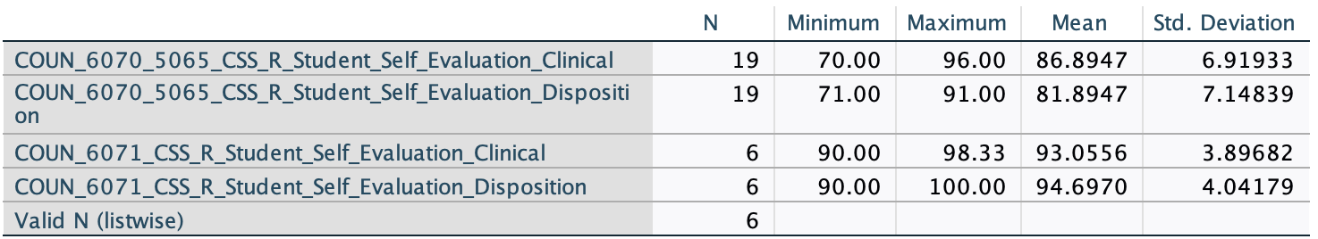

Spring 2025 Internship and School Counseling Student Self-Evaluations CCS-R

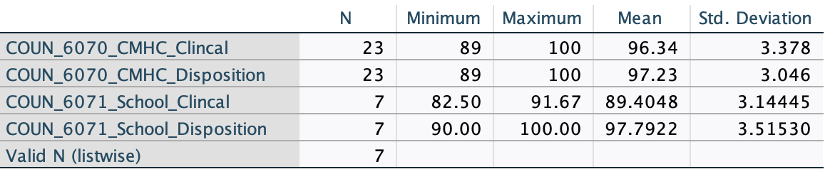

Summer 2025 Practicum Students' Self-Evaluation CCS-R

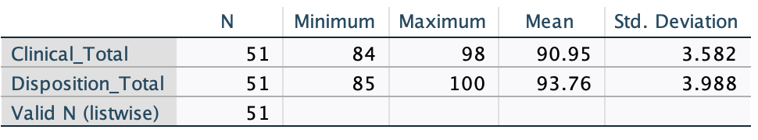

Summer 2025 Internship Students' Self-Evaluation CCS-R

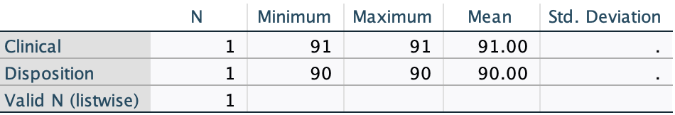

Student Evaluations of Site and Supervisor Return to Top

Fall 2024 Practicum, Internship, and School Internship Evaluations of Site and Supervisor

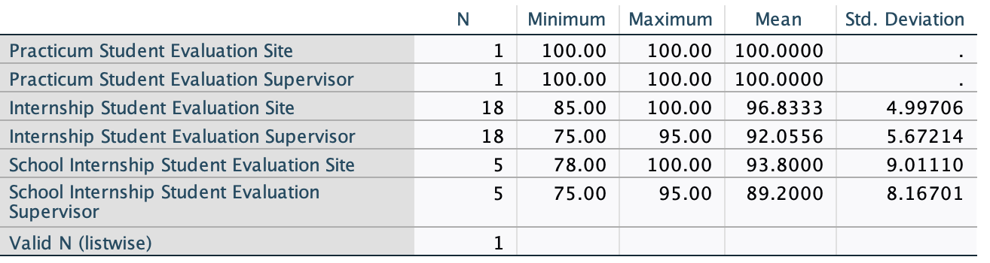

Spring 2025 Practicum, Internship, and School Internship Evaluation of Supervisor and Site

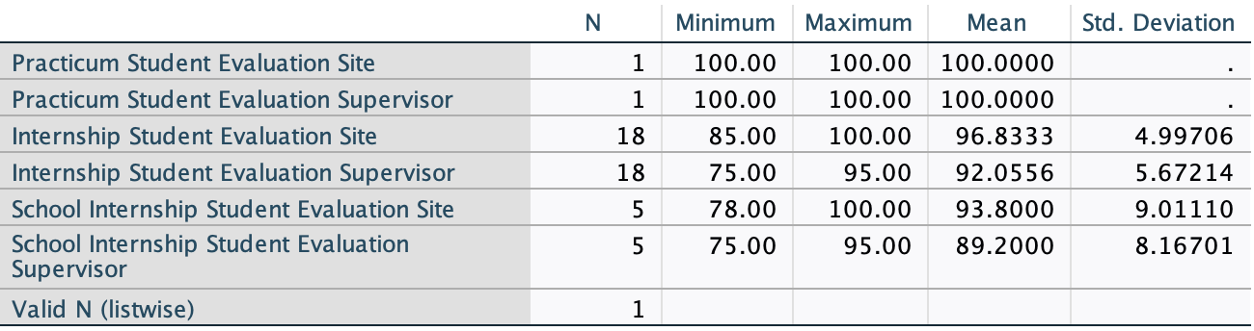

Summer 2025 Practicum and Internship Evaluation of Supervisor and Site

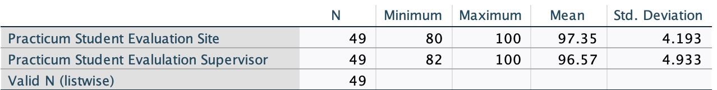
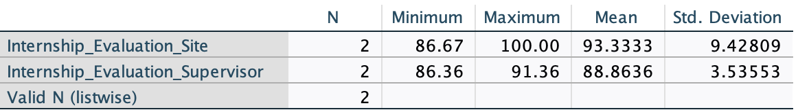

Trend Analysis Results Return to Top

Spring 2025 Internship

Faculty Results

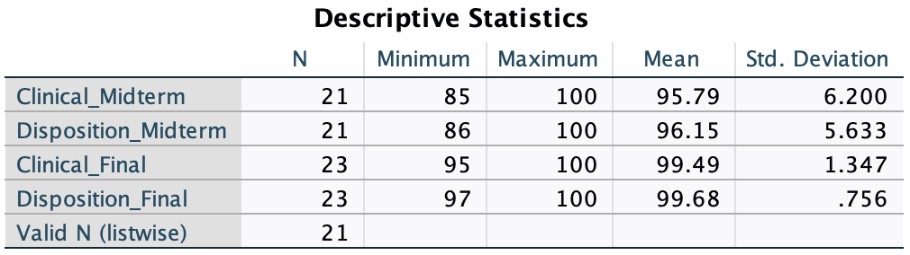

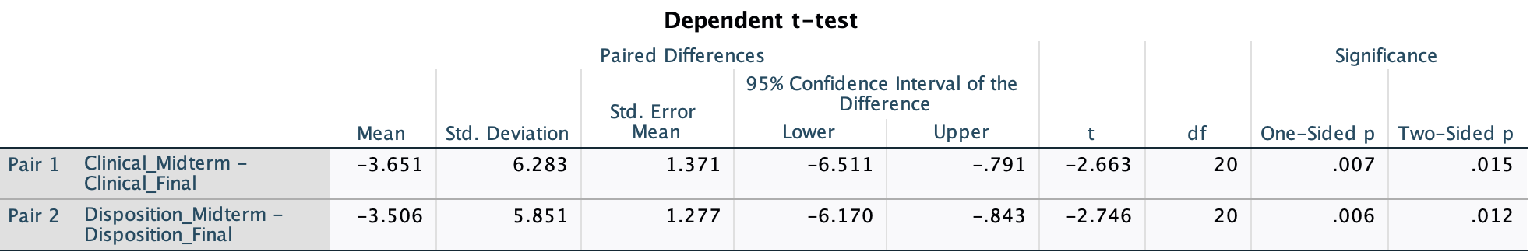

Site Supervisor Results

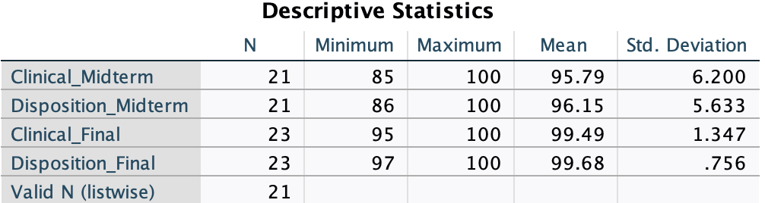

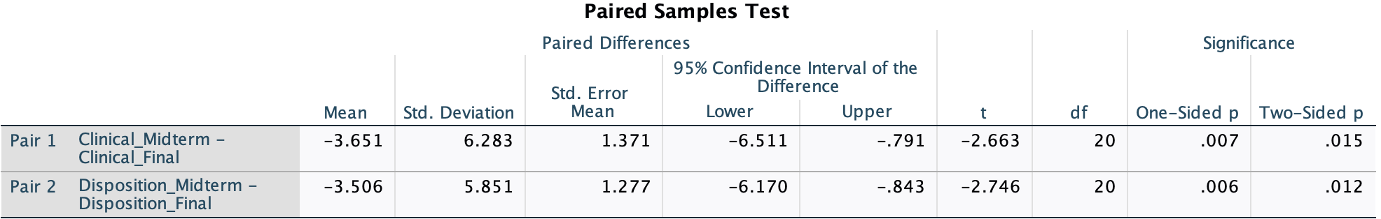

-----------------------------------------------------------------

Spring 2025 School Internship Return to Top

Faculty Results
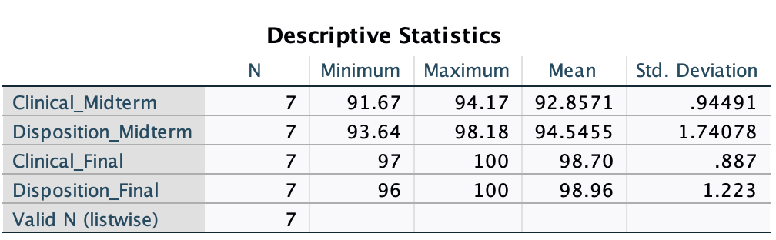

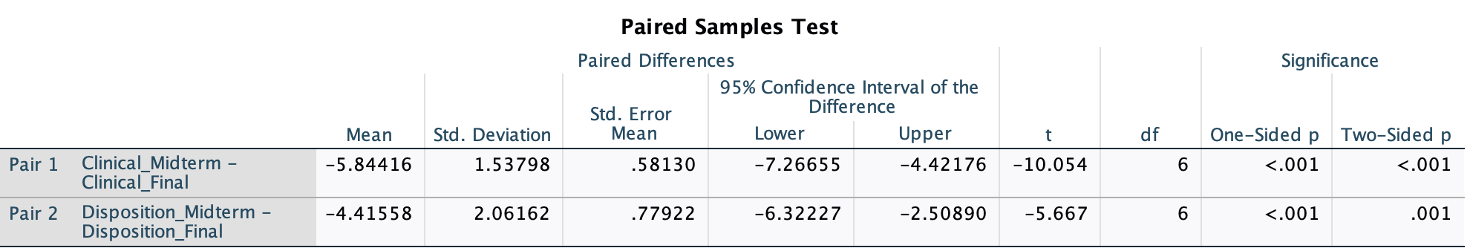

Site Supervisor Results Return to Top

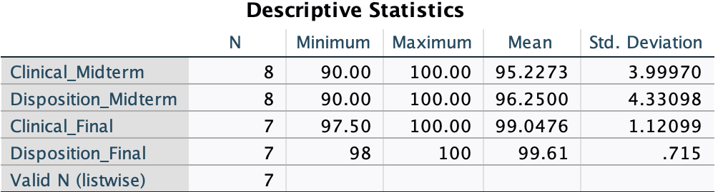

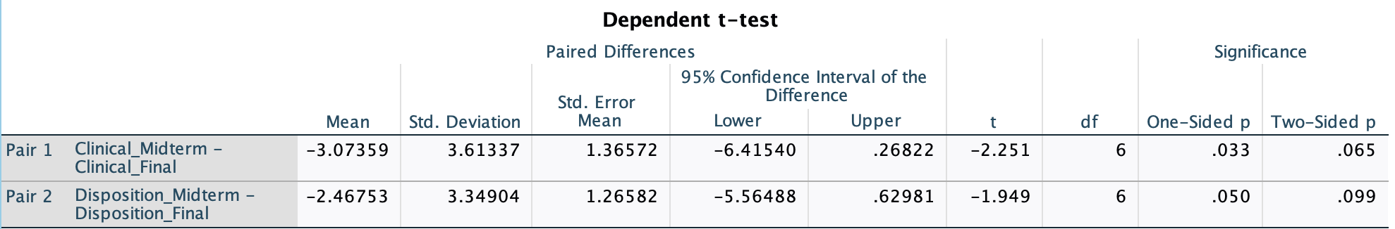

Summer 2025 Practicum Return to Top

Faculty Results

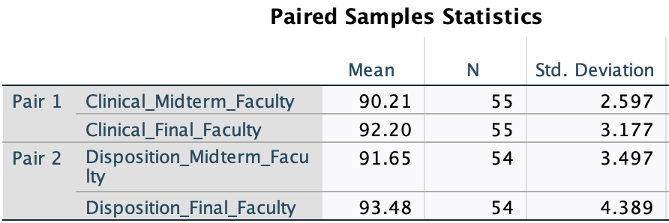

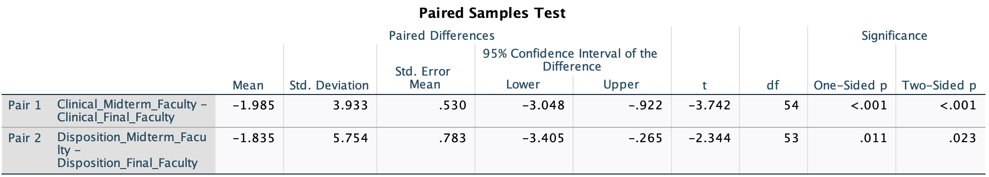

Site Supervisor Results
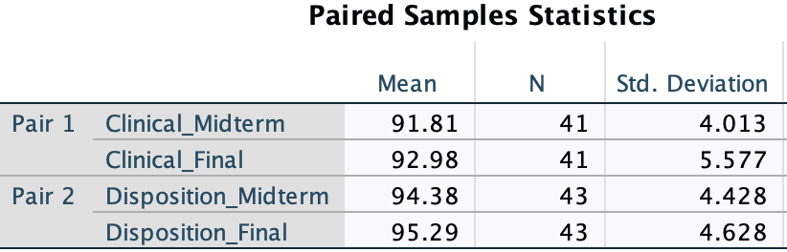

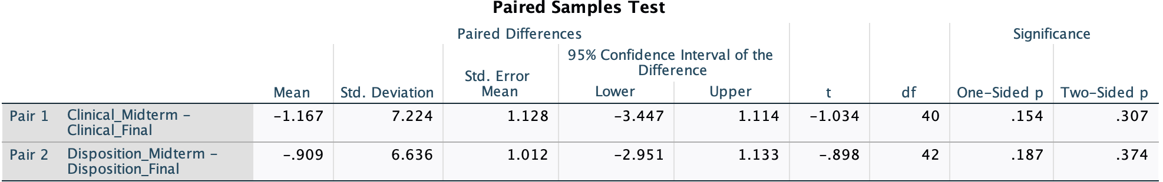

----------------------------------------------------------------------

Summer 2025 Internship Return to Top

Faculty Results
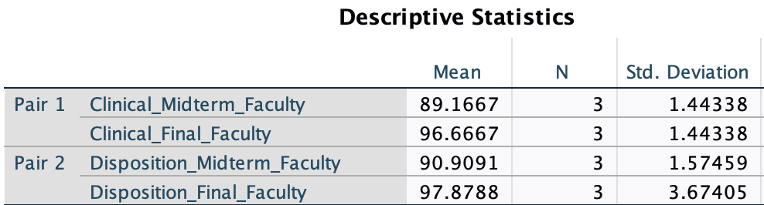

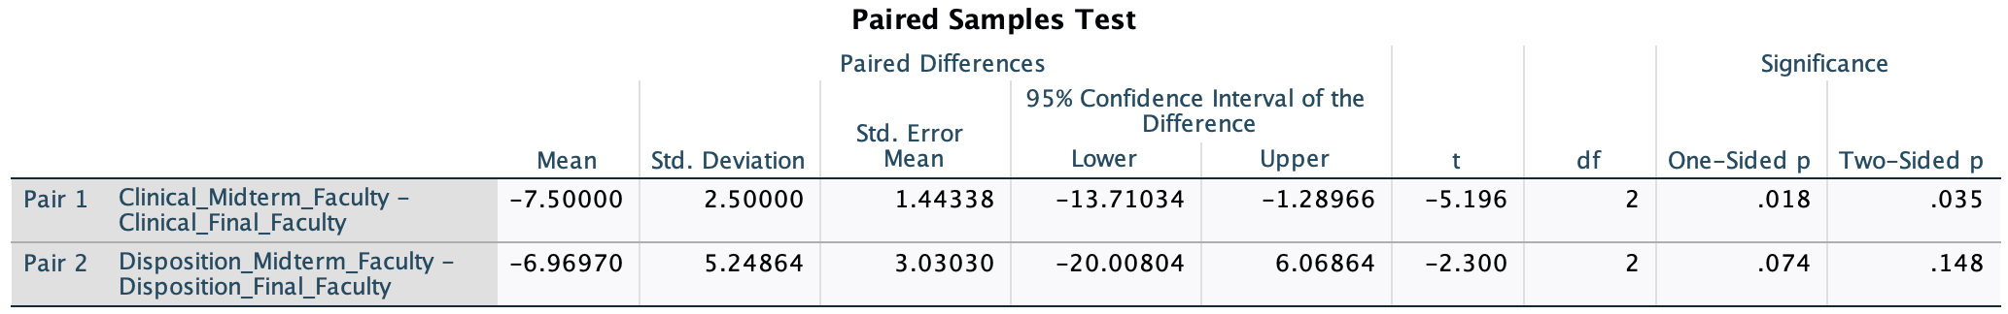

--------------------------------------------------------------

Site Supervisor Results
