AGENDA – ULM Faculty Senate
Date: 4/16/26; 12:30-2 pm, Location: Teams only
Please contact the faculty senate at: facultysenate@ulm.edu if you have any questions or comments related to the agenda.

The Louisiana Open Meetings Law can be accessed by scanning the QR code. | 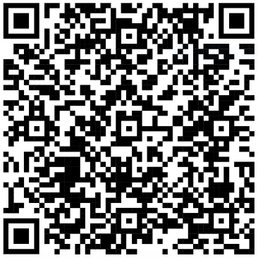

*Attendance will be taken through MS Teams.
*Information related to guest participation, can be found on the faculty senate’s open meetings law guidance page.
*The faculty senate reserves the right to enter into Executive Session, if needed, in accordance with R.S. 42:11 et seq.
Approval of Minutes
Reports of Committees
Unfinished Business
NA
New Business
Announcements
Accessibility application to faculty senate
Year in review: senate accomplishments and pending items for the 2026-27 academic year
Open Forum
*Agenda is tentative and may change
*Sequence of agenda item discussion during meetings is subject to change

