HEALTH SCIENCE PRACTICUM MANUAL
REQUIREMENTS AND GUIDELINES



University of Louisiana Monroe
700 University Avenue
Monroe, Louisiana 71209-0440
Sugar Hall 156

Contact Information

Practicum Coordinator
Dr. Jodi Bower
Health Studies Practicum Coordinator
Assistant Professor| Health Studies
Sugar Hall 156B
Office | 318-342-3060
Email | jdbower@ulm.edu

Health Studies Program Director
Dr. Jessica Dolecheck
Professor
Health Studies Program Director| College of Health Sciences
Sugar Hall 156A
Office| 156A
Email | dolecheck@ulm.edu

Table of Contents

Contents Page #

Course Description and Objectives…………………………………………………………......3

Pre-Practicum Checklist………………………………………………………………………...4

Practicum Checklist…………………..………………………………………….………...........5

Researching a Practicum Site…………………………………………………………............6-7

Student Requirements and Guidelines…………………………………...…………....…....8-10

Expectations for Professional Behavior While at Practicum…………………………......….11

Intent to Register for Practicum Form…………………………………………………….….12

Site Supervisor/Practicum Site Responsibilities…………………………………………..….13

Background and Drug Screens for Affiliation Agreements……………………….……...14-15

Drug Screen/Background Check and Release Form………………………………….......16-17

Course Acknowledgement Form………………………………………………………………18

Health Science Practicum – HLST 4003

Course Description

The Health Science Practicum (HLST 4003) is a 3-credit hour course designed to place a student at a healthcare agency during their senior year. Its purpose is to allow students the opportunity to have on-the-job experiences in healthcare while under supervision in an approved agency. It also allows students to explore their interests and career options while in school and relate course-work to real-world employment. Students must register for HLST 4003 and serve a minimum of 104 hours on site at the agency during the semester.

Objectives

At the conclusion of the course, the student will be able to:

- Observe and actively participate in decision-making and strategic planning involved in program design, implementation, and evaluation at the healthcare agency.

- Perform all roles and responsibilities effectively, demonstrating professionalism and a strong work ethic.

- Identify organizational techniques for responding to pressure from social, political, regulatory, competitive and other external forces.

- Explain the purpose of selected internal programs such as community education, employee education, and quality improvement; then describe them in relation to the organization.

- Describe management styles observed and self-critique personal management style relative to site observations.

- Apply principles of problem-solving and decision-making to one of the organization’s problems and present solutions in PowerPoint presentation to administrative personnel.

Pre-Practicum Checklist

(Students who do not meet all of the requirements on this checklist at the time of submission of the Intent to Register form will not be allowed to enroll in practicum.)

Pre-Practicum

 Meet academic requirements.
- Students must have declared a major in Health Studies.
- At least 90 hours completed
- Students must be in good standing with the University.
- Minimum 2.0 Cumulative G.P.A
- 2.75 HLST G.P.A or higher, with “C” or better in all HLST courses
- Students must have completed all 2000 and 3000 level HLST courses.
*Failure to maintain satisfactory GPA requirements will result in removal of enrollment in HLST 4003.

 Complete the “Intent to Register for Practicum” form found on the Health Studies Program Advising Moodle page or Health Studies website and e-mail it to Dr. Jodi Bower at jbower@ulm.edu along with your resume’.

Students should provide additional information on the Intent to Register such as possible sites or career interests. These can be chosen from the list of current practicum sites to which the Health Studies Program has already established contracts. If a student wishes to complete their Practicum hours at a site that is not on the approved list, the student should contact the Practicum Coordinator as soon as possible and before submission of the Intent to Register. Students will be asked to contact the facility individually, and if the site agrees, the student should provide the site’s information (name of the facility, type of facility, address, phone number, contact person, e-mail address, and any other important information.) to the Practicum Coordinator.

 Interview with Practicum sites when instructed by Practicum Coordinator.

 Obtain final approval from Practicum Coordinator for practicum site.

 Register for HLST 4003. HLST 4003 is a non-printing course so it will not show on the schedule in Banner. The Practicum Coordinator will provide you with the CRN for registration purposes. (Note: There is an extra $250.00 Practicum fee associated with this course. This fee is in addition to normal fees associated with the course. The fee is assessed with other semester fees.)

Practicum Checklist

Practicum

 Meet with Practicum Coordinator and site supervisor as needed.

 Complete Practicum Orientation (Topics to be covered: Professionalism, HIPAA, Safety, Harassment, Blood borne Pathogens, Code of Conduct, Patient Rights, Customer Service)

 Student and site supervisor complete Academic Learning Objective Agreement Form.

 Complete Practicum Information form.

 Complete weekly work logs, discussion postings, and assignments.

 Site supervisor completes mid-term evaluation. The site supervisor reviews the evaluation with student and the student returns form to the Practicum Coordinator.

 Site supervisor completes final evaluation the last week at practicum site. The site supervisor reviews the evaluation with student and the student returns form to the Practicum Coordinator.

 Student completes E-Portfolio.

 Student completes and submits remaining forms as applicable.

 Site Supervisor completes the Student Academic Practicum Learning Objective Evaluation form and the student returns form to the Practicum Coordinator.

 Student prepares and submits a Reflection paper on the practicum experience.

 Student completes Practicum Site Evaluation form.

Researching a Practicum Site

Potential Practicum Sites

The practicum experience allows ULM to collaborate with the community in educating students. Although healthcare agencies vary, potential practicum sites include: 1) pharmaceutical companies where the student collaborates with a pharmaceutical sales representative; 2) hospitals where the student partners with business office administrators or unit supervisors; 3) rehabilitation centers where the student partners with marketing directors; and 4) nursing homes where the student partners with administrators.

Students, in conjunction with the practicum coordinator, are responsible for finding and securing their own practicum sites. However, the Health Studies Practicum Coordinator may be able to provide information about potential sites. Additional information regarding the Health Studies Practicum is listed on the program’s website.
How to Secure a New Practicum Site
Health Studies Students, especially online students, may be asked to identify and help secure a NEW practicum site for their practicum.
Steps in securing a NEW site:
1. Re-read the definition of Practicum.
2. Think about your interests and where you might like to complete a Practicum.
3. Remember, many times, that Practicum could open employment opportunities for you upon graduation.
4. Research and identify 2-3 NEW healthcare sites that are reputable, longstanding that are in your area and offer services that you are interested in working.
5. Identify a contact person that is in leadership position at the NEW site that would be willing to talk with you about a practicum opportunity.
6. Before talking with the person, talk with Practicum Coordinator about your approach.
7. Also, before talking with the person, practice explaining what a practicum is, which would include total number of hours, your job responsibilities while there, what you hope to gain from being there, type of projects you could work on while at the site and how your practicum could benefit the company.
8. Arrange for a time to talk with the contact person.
9. Then, send the contact names to Dr. Bower at jbower@ulm.edu.

Be sure to gather as much information as possible about the practicum site. Information should include:

● Name of Organization
● Type of Organization
● Address and Phone number of Organization
● Name of Contact Person and Responsibilities
● Web-site
● Type of Programs available
● Target of Community Needs
● Business Hours

Upon receipt of this information, the Practicum Coordinator will begin discussions and potential contract negotiations with the site. Providing contact information does not guarantee the student will be placed at that site. Contract negotiation and approval can take months therefore students should begin this process very early.

ULM
Health Science Practicum (HLST 4003)

STUDENT REQUIREMENTS and GUIDELINES

Registration will not be permitted without approval from Health Studies Practicum Coordinator.

Practicum Requirements/Guidelines:

- The student must contact the Practicum Coordinator prior to early advising the
semester before registering for Practicum to secure permission for enrollment and discuss course requirements. In collaboration with the Practicum Coordinator, the student is responsible for contacting, negotiating, and securing a site for placement. The final decision of a student to be allowed to attend practicum at a given site rests solely on the practicum site.

When multiple students have requested the same site and the site can only take a limited number of students, ranking of students based on GPA will be performed. Those with the highest GPA will have priority for the site.

In the event that a site(s) does not choose a student and another site can’t be secured, the student will not be allowed to attend practicum that semester and must resubmit their intent to register information again the following semester.

2) The student must submit the “Intent to Register” form by the established deadline and
must meet all academic requirements on that date.

3) The student must prepare a Practicum resume’. The resume’ should contain the student’s
interests, professional, educational, and personal histories. This will allow for the
communication of the student’s interests with the Practicum Coordinator and site
supervisor.

3) The student must meet all academic requirements to register for Practicum (HLST 4003).

- Students can only attend practicum at contracted sites.

- Student registers for HLST 4003. The CRN# is e-mailed only to approved students. Students will not find HLST 4003 listed in the schedule of classes in Banner.

- Once a student has registered for Practicum, they cannot withdraw from the course without the express permission of the Program Director or Practicum Coordinator. Only students with extenuating circumstances will be allowed to withdraw from the course.

- The student must function professionally at the site.

- The student must comply with the policies and procedures of the site and university.

- The student must successfully complete a minimum of 104 hours at the site
during the semester in order to earn the 3 hours of credit for (Practicum). Typically, sites only allow students to obtain practicum hours between 8:00 am – 5:00 pm, Monday through Friday. Occasionally, there may be activities after hours or on weekends.

11) The student is required to provide his/her personal transportation and living arrangements
while placed in practicum. Student is responsible for their personal safety. Student must
always be aware of their surroundings.

12) The student cannot receive payment from the practicum site for hours worked to satisfy
the requirements of HLST 4003.

13) There is an extra $250.00 Practicum fee associated with this course. This fee is in
addition to normal fee associated with the course. The fee is assessed with other
semester fees. The student may be expected to pay for police checks, background
checks, drug testing, and parking if required by the site.

14) A written report of the practicum experience must be submitted at the end of the
semester. In addition, the practicum site supervisor will be required to complete a
mid-term evaluation, final evaluation, and learning objectives evaluation assessing the student’s performance. Student will maintain weekly work logs. This statement will be signed by the student as well as the Site Supervisor each week. Any falsification of hours worked may result in disciplinary procedures according to the ULM Student Code of Conduct.

- The student is subject to drug and alcohol testing as stated in the School of Health Professions and School of Nursing Substance Abuse Policy (See ULM – SHP website for specific policy) and/or the policy of the Practicum site. Student is responsible for all costs associated with drug/alcohol testing

16) The student is strongly recommended to maintain personal health insurance.

17) Some sites require evidence of additional immunizations. Student is responsible for
meeting all immunizations requirements of the site. All costs associated with immunizations and testing are the responsibility of the student. Students who do not meet site-specific requirements will not be allowed to attend practicum which may impact their graduation date.

18) Student must dress professionally and honor the dress code of the practicum site.

Some sites require a name tag. Names tags can be obtained from Unique Trophy in West Monroe, LA. Their phone number is 318-322-2444. The cost is approximately $6. The name tag must contain your “name” and “ULM student”.

19) Students must keep all patient information confidential and follow the regulations under
the Health Insurance Portability and Accountability Act (HIPAA). Any breach of patient
confidentiality will result in immediate removal from the course with an F letter grade.

20) The student cannot take photos of patients at any practicum site due to HIPAA. Students
must obtain permission from the site supervisor prior to any other photos (non-patient)
being taken.

21) If an injury occurs at the practicum site, the student should seek help immediately. The
injury should be reported immediately to the site supervisor and ULM Practicum
Coordinator. The practicum coordinator will inform the Health Studies
Program Director of the injury.

The University does not provide insurance coverage for students traveling in their personal vehicle for academic internship/practicum activities. The student is responsible if involved in a wreck or any other type of vehicle accident.

22) Students must report any issues to the Practicum Coordinator that may arise at the
Practicum site that may impede the learning process.

23) This practicum experience does not guarantee any employment at any practicum site.

24) International students should direct all employment questions to the ULM director of international students.

Expectations for Professional Behavior While at Practicum

● Arriving to practicum ahead of time.

● Appropriate discussions and questions during practicum.

● Demonstrates full attentiveness while on site (Absolutely no sleeping while at the practicum site. You will be asked to leave if this occurs!).

● No use of cell phones or laptops, etc. (period!!) without prior permission from faculty or site supervisor.

● Prepared for practicum, organized and ready to participate.

● Dress is professional: no shorts of any kind, no see-thru apparel or bareback, no sheer or tight-fitting attire, no visible tattoos or body piercing(s), no tank tops, no jeans with holes or rips, no flip flops or tennis shoes, no exercise apparel.
Students at practicum must follow the dress code of the practicum site!

● Men should wear a nice collar shirt/golf shirt or dress shirt with professional full-length pants. Students at practicum must follow the dress code of the practicum site!

● Women should wear a nice blouse/shirt dress or sweater and/or professional dress pants/skirt. Students at practicum must follow the dress code of the practicum site!

● No disruptive behavior during practicum.

● Do not work on other class assignments or projects during practicum – this is disrespectful!

● Complete all assignments according to timelines and in the correct format. Do not wait until the last minute to have the site supervisor sign your work logs.

● Independently complete all assignments without assistance from others.

● Use appropriate discussions/questions with the professor/ classmates/site supervisor
during the course.

● Show respect to your fellow students, professor, site supervisor, site staff and other faculty.

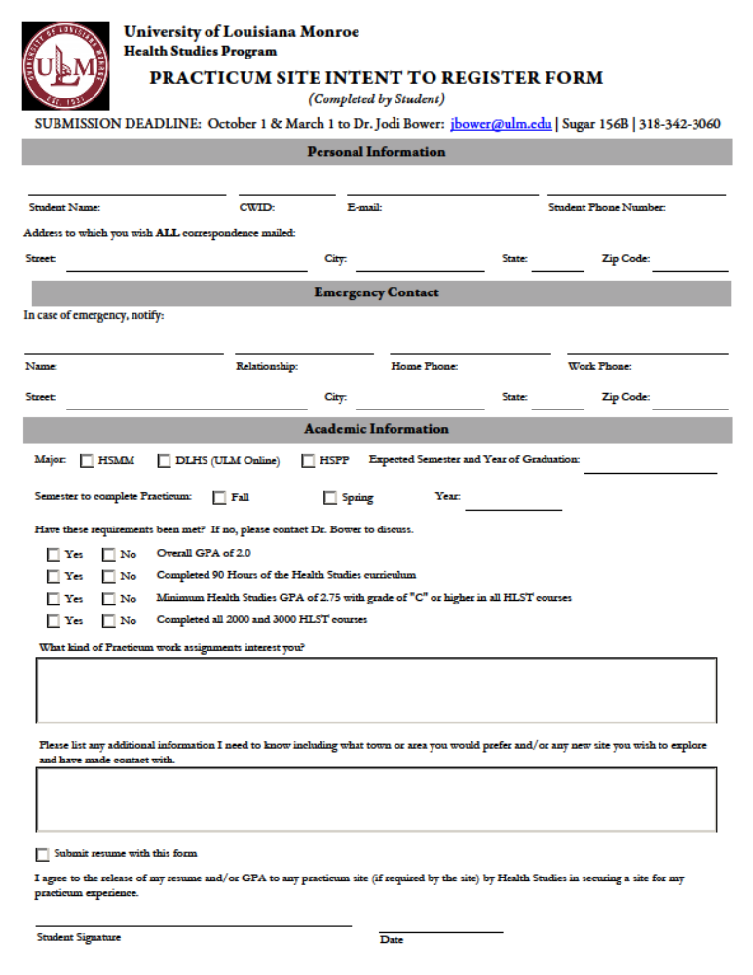

SITE SUPERVISOR/PRACTICUM SITE /RESPONSIBILITIES

The site supervisor/agency is expected to provide adequate professional supervision for the practicum student. The site supervisor/agency is expected to do the following:

- Provide student with an appropriate orientation to the agency.

- Provide student with any necessary agency forms for signing regarding confidentiality/HIPAA or other agency policies.

- Work in conjunction with student in developing learning objectives. Select objectives based on the students needs. Clearly define goals and objectives. They are the foundation for learning projects and measurements.

- Complete Academic Learning Objective Agreement.

- Provide student with a realistic and meaningful experience.

- Approve the student’s weekly log each week. The site supervisor’s signature verifies the accuracy of information documented by the student.

- Complete mid-term and final student evaluations. Each mid-term and final evaluation should be reviewed with student prior to returning to the Practicum Coordinator.

- Complete the Academic Learning Objective Evaluation

- Communication is very important during the practicum experience. Please notify the Practicum Coordinator of any situations or behaviors regarding the student, which may be problematic.

Background and Drug Screens - Affiliation Agreements

Please note, this information is specific to Health Sciences, for Pharmacy information, view their site.

Background Checks and Drug Screenings (Prior Disclosure)
Background checks and drug screening tests are required in some SHP and SON departments before a student can initiate a clinical rotation or internship. Some programs may require students to disclose to program personnel information from their past which may surface, prior to initiation of the background check or drug screen. In such cases, program personnel should have specific written recommendations outlining the students’ options and action plan. There is a no tolerance policy for failed drug screen.

Initial Background Checks and Drug Screening
- College wide policies for Background Check and Drug Screening must meet contractual requirements for each internship or clinical facility site per the affiliation site agreement and/or program policy.
- The affiliation agreement dictates the type and screening criteria required.
- Students applying for internships or clinical facility site rotations must be notified in writing and sign an acknowledgement of the following:
- That they will be subject to background checks and drug screening.
- That payment for screening is the student’s responsibility.
- That they give permission for the Associate Dean to view the results on a secure website.
- That they understand that the Dean or Associate Dean will report to the Program Director or their designee that screening results did or did not include information of concern.
- That they understand that if the background check reveals screening “information of concern”, they may not be allowed to commence their internship or clinical facility site rotation.
- That they understand that if the drug screening reveals “information of concern”, they will not be eligible to commence their internship or clinical facility site rotation, and that they will be dismissed from the SHP and SON as the SHP and SON has a no tolerance policy for a failed drug test.
- That any appeals should be submitted to the Dean’s office.
- That they understand that CertifiedBackground.com will archive all records and that hardcopy printing of results by the Associate Dean is available but not anticipated routinely. Records will be maintained pursuant to ULM’s record retention policy.
- That additional testing could be required at any time if suspicious behavior is observed.
- Programs will notify pre-intern or clinical facility site rotation students that they must complete a Background Check and/or Drug Screening.
- Students will be given a program account number and directed to the website for www.CertifiedBackground.com where they will register and pay for the Background Check and Drug Screening.
- Students should proceed according to the instructions.

Drug Screening and Suspicious Behavior
- If a student displays suspicious behavior during a rotation, it is the responsibility of the facility and/or the clinical supervisor at the facility to notify the Program Director.
- The Program Director will notify the Associate Dean of the concern who will confer with the Dean to determine whether a drug screen should be initiated.
- If the determination is made to initiate a drug screen, the Program Director will notify the faculty/clinical supervisor who will notify the student.
- The Associate Dean/Dean’s office will contact Lab Corp or the designated laboratory that a student will arrive for a drug screen within two hours and that the SHP and SON will pay for the drug screen.
- The Associate Dean/Dean’s office or designee will contact the cab company to request round trip transportation to the lab facility.
- Once the cab arrives, the faculty/clinical supervisor will pay the cab driver for round trip transportation of the student.
- The Program Director will submit the receipt for reimbursement to the Dean’s office.
- The same policies and procedures as were used in the initial drug screening apply: that if the drug screening reveals “information of concern”, they will not be eligible to continue their internship or clinical facility site rotation, and that they will be dismissed from the SHP and SON as the SHP and SON has a no tolerance policy for a failed drug test.
- They have the right to appeal to the Dean’s office.
- They understand CertifiedBackground.com will archive all records and that hardcopy printing of results by the Associate Dean is available but not anticipated routinely. Records will be maintained pursuant to ULM’s record retention policy.

UNIVERSITY OF LOUISIANA AT MONROE
Health Studies

DRUG SCREENING/ BACKGROUND CHECK ACKNOWLEDGEMENT
I understand that before beginning practicum in the Health Studies program I may be subject to a drug screening and a background check according to contractual requirements of agreements with practicum sites. I understand that I am responsible for the cost of these procedures and that the results of the procedures will be released to the University of Louisiana at Monroe, College of Health and Pharmaceutical Sciences (CHPS)-Dean/Associate Dean and I give permission for the Associate Dean to view the results on a secure website. I understand that the Dean or Associate Dean will report to the program director or their designee that screening results did or did not include information of concern. I understand that if the background check reveals information of concern, that I may not be allowed to commence to my practicum/internship. Additionally, I understand that if the drug screening reveals that a positive finding exists, that I will not be eligible to commence to my practicum/internship, and that I will be dismissed from the CHPS, as the CHPS has a no tolerance policy for a failed drug test. Any appeals should be submitted to the CHPS Dean’s office. I also understand that CertificedBackround.com/CastleBranch will archive all records and that hardcopy printing of results by the Associate Dean is available but not anticipated routinely. Records will be maintained pursuant to ULM’s record retention policy. Additional testing could be required at any time if suspicious behavior is observed.
and RELEASE FORM

________________________________PRINT NAME

_____________________________ __________

SIGNATURE DATE

UNIVERSITY OF LOUISIANA AT MONROE

Health Studies

DRUG SCREENING/ BACKGROUND CHECK RELEASE FORM

I understand that before beginning practicum in the Health Studies Program I may be subject to a drug screening and a background check according to contractual requirements of agreements with practicum sites. I understand that I am responsible for the cost of these procedures and that the results of the procedures will be released to the University of Louisiana at Monroe College of Health and Pharmaceutical Sciences-Dean/Associate Dean. If there is any information of concern as a result of these procedures, I understand that I will not be allowed to begin the practicum component of the program which may affect my ability to graduate.

_________________________________________PRINT NAME

________________________________________
_________________________________________ ____________
STUDENT SIGNATURE DATE

Practicum
Course Requirements Acknowledgement

I, ___________________________________, agree to keep all sensitive information, which includes but not limited to patient information, proprietary information, and budget information, of the practicum site confidential. I also understand that any breach of confidentially or any provision of the Health Information Portability and Accountability Act (HIPAA) will result in dismissal from the HLST 4003 (with F letter grade) and legal sanctions may be filed against me from the practicum site.

If background checks and/or drug screens are required by the university or practicum site, I give my permission for these to be performed and the results of these be released to university officials and the practicum site. I also agree to abide by all university and practicum site policies related to this. I also give my permission for any of my relevant education information to be released to the practicum site, as requested.

I recognize and acknowledge that some practicum sites have immunization requirements for students. I understand that failure to meet the requirements of the practicum site may result in dismissal from the practicum site. I give my permission for University of Louisiana at Monroe, Health Studies Program, to release my immunization information, including TB, to the site if requested.

I understand that failure to abide by any university or practicum site policies may result in dismissal from the course (HLST 4003) (with letter grade of F) and university.

Student Name________________________________________________

Student Signature: ____________________________________________

CWID ______________________________________________________

Date _______________________________________________________

