Adding Alt Text to Images in PowerPoint

Choose the image


Click on the image
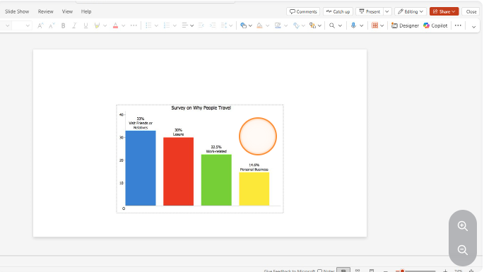

Click “Alt Text” icon
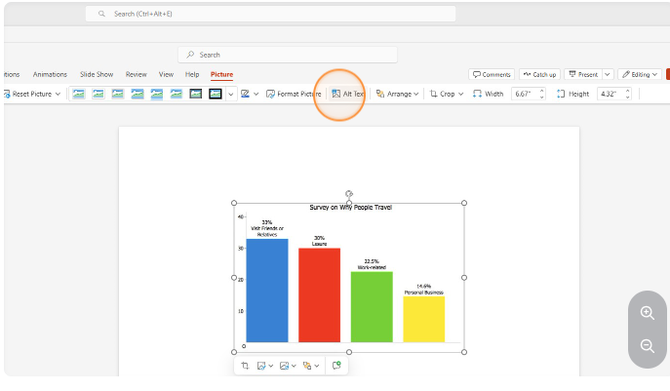

Click this field and describe the purpose of the image
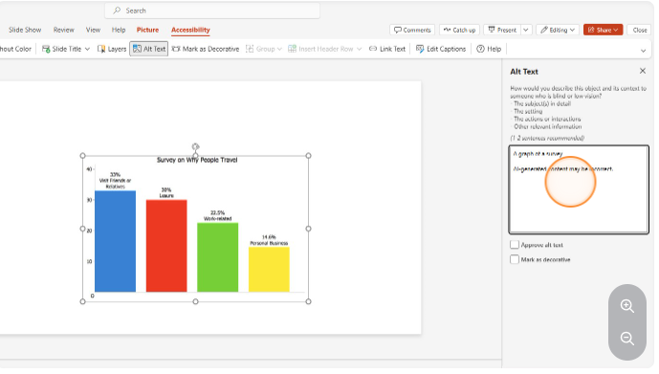

Why it matters
Alt text allows screen reader users to understand images, charts, icons, and graphics in your slides. Without alt text, students using assistive technology may miss important visual information. Missing alt text is one of the most common accessibility flags in Panorama and a key requirement for WCAG 2.1 AA compliance.

Common Mistakes
- Leaving Alt text blank
- Writing “image of” or “picture of”
- Writing long paragraphs of unnecessary detail
- Adding alt text to grouped objects instead of individual meaningful elements

