ADDING ALT TEXT TO IMAGES IN WORD

Step 1: Open the Document with Images

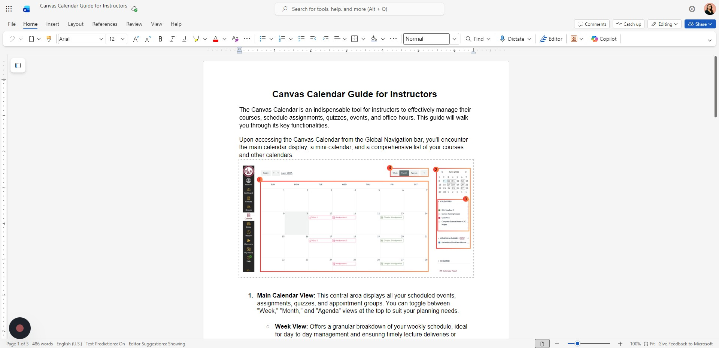

Step 2: Right Click on the Image

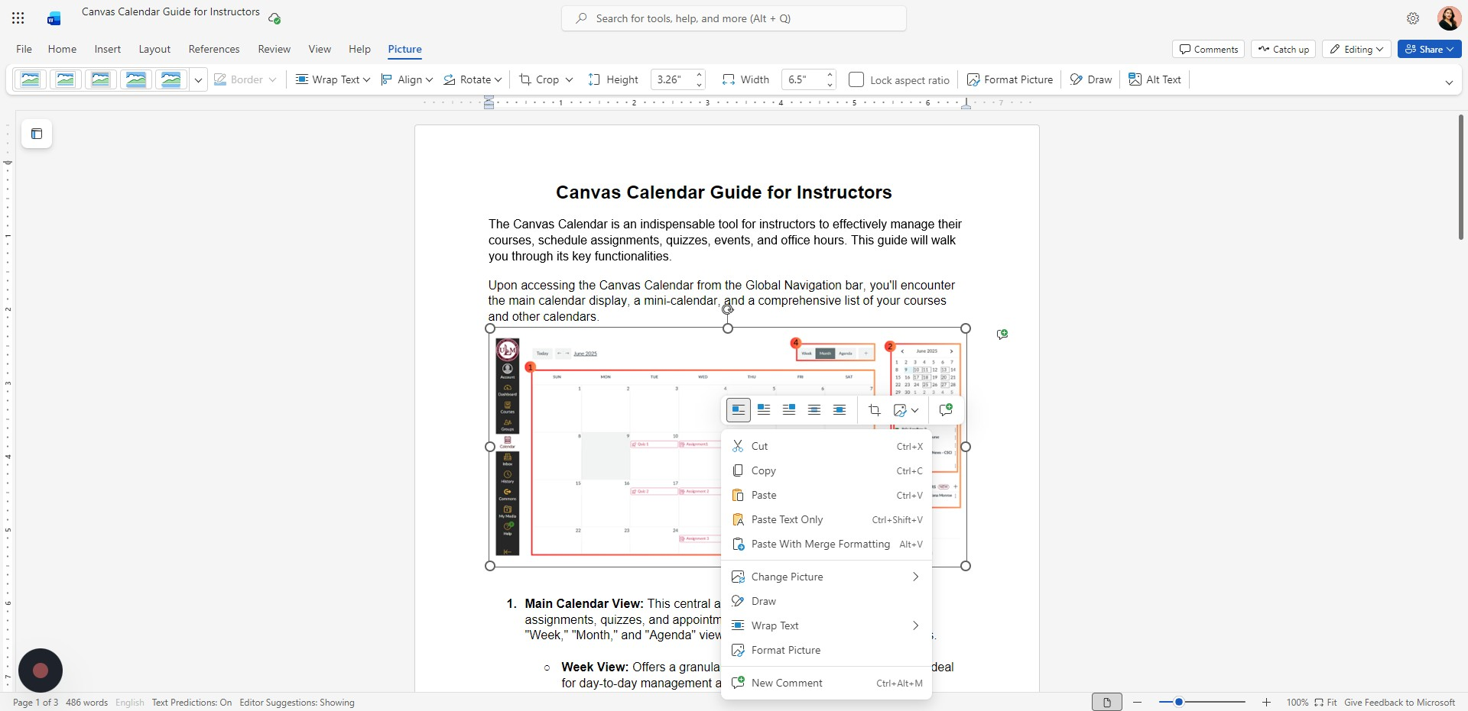

Step 3: Click "Format Picture"

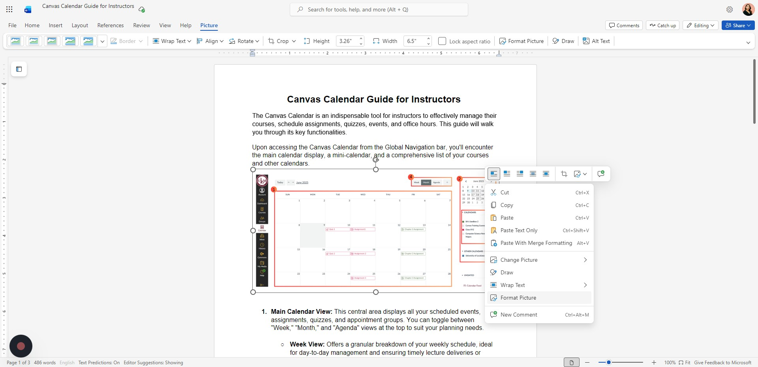

Step 4: Click the "Description" field and Add a Detailed Description of the Image.

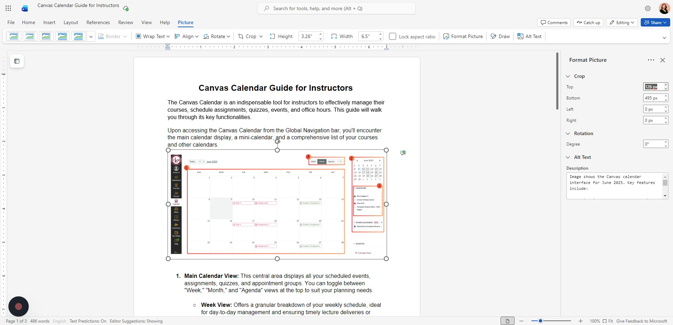

What to Write in the Description Field
When adding alt text, describe the image clearly so someone who cannot see it understands its meaning.
Include:
- What the image shows (main subject)
- Important details (text, labels, actions, data)
- The purpose of the image (why it is there)
- Any information needed to understand the content
If it’s a chart or graph:
- Type of chart (bar graph, pie chart, etc.)
- What the data represents
- Key trends or important numbers
If it’s decorative only:
- Mark it as decorative instead of writing a description

Purpose of Alt Text
Alt text helps:
- Screen reader users understand visual content
- Make documents accessible and ADA-compliant
- Ensure important information is not missed
- Improve clarity for all users

Common Mistakes to Avoid When Writing Alt Text
- Writing “image of…” or “picture of…”
- Being too vague (e.g., “Graph” or “Screenshot”)
- Adding too much unnecessary detail
- Repeating the caption word-for-word
- Leaving meaningful images without alt text
- Adding descriptions to decorative images instead of marking them as decorative
- Forgetting to describe important text shown inside the image
- Ignoring key trends or conclusions in charts and graphs

Good vs. Bad Alt Text Examples
Example 1: Informational Image
Bad:
“Students studying.”
Good:
“Three college students sitting at a library table working on laptops and reviewing printed notes.”
Example 2: Chart or Graph
Bad:
“Bar graph of sales.”
Good:
“Bar graph showing monthly sales from January to June, with sales increasing steadily from $5,000 in January to $12,000 in June.”
Example 3: Screenshot of a Website
Bad:
“Canvas homepage.”
Good:
“Canvas dashboard displaying course cards for Math 1001, English 2000, and Biology 1020, with the To-Do list on the right side.”

