Creating Accessible Tables in Microsoft Word

IT Help Guide

Why It Matters: An accessible design improves usability for all users, ensuring people with disabilities can access the same information as everyone else, and the table works properly with assistive technology. The table design has to meet WCAG 2.1 AA standards (Web Content Accessibility Guidelines).

Step 1. Insert a Table Correctly.
- Go to the Insert tab at the top left-hand portion.
- Select Table and Choose the number of Rows and Columns.

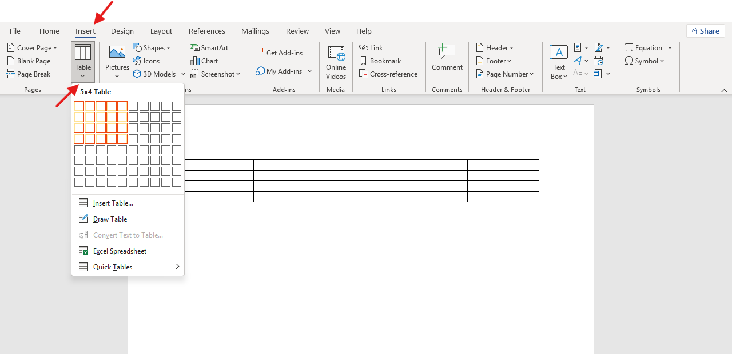

Step 2. Add a Table Title
- Click above the table.
- Click the Title style in the Home tab.
- Type a clear, descriptive title.

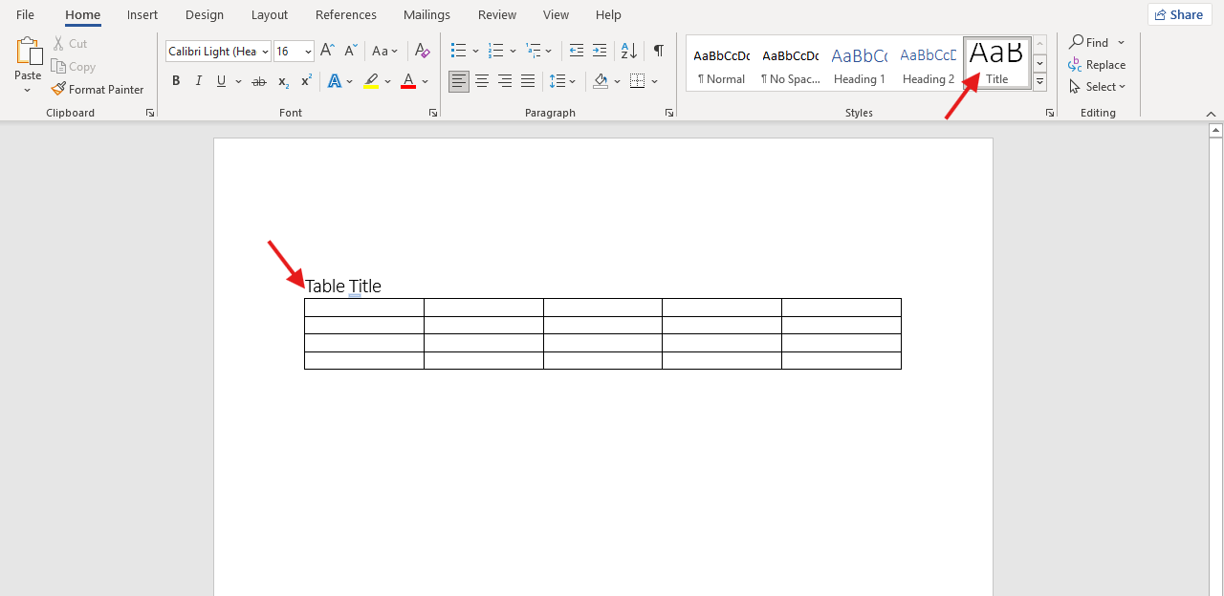

Step 3. Create a Header Row.
- Click inside the table.
- Go to the Table Design tab.
- Click Header Row in the Table Style Options.

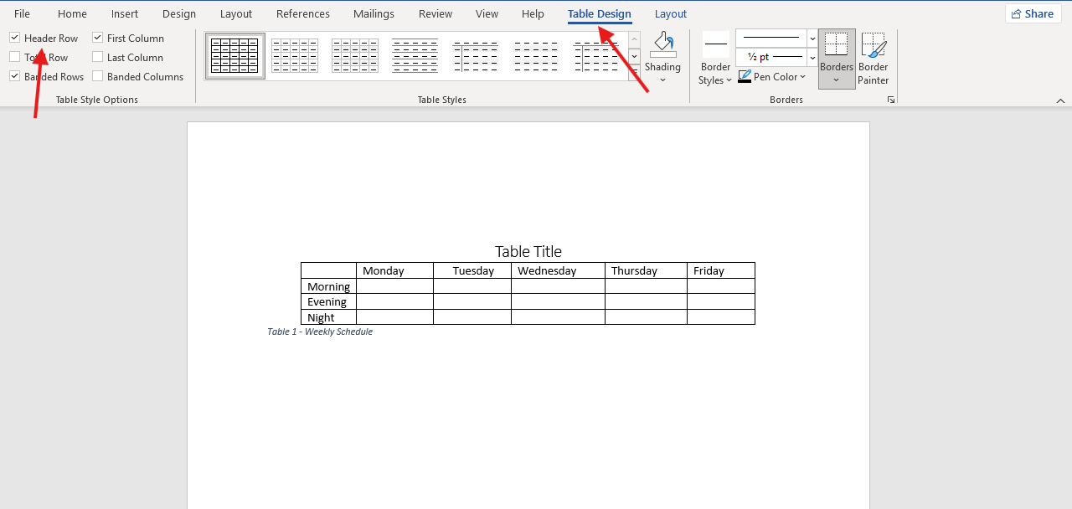

Step 4. Add a Caption
- Click on the table.
- Go to the References tab.
- Click Insert Caption.

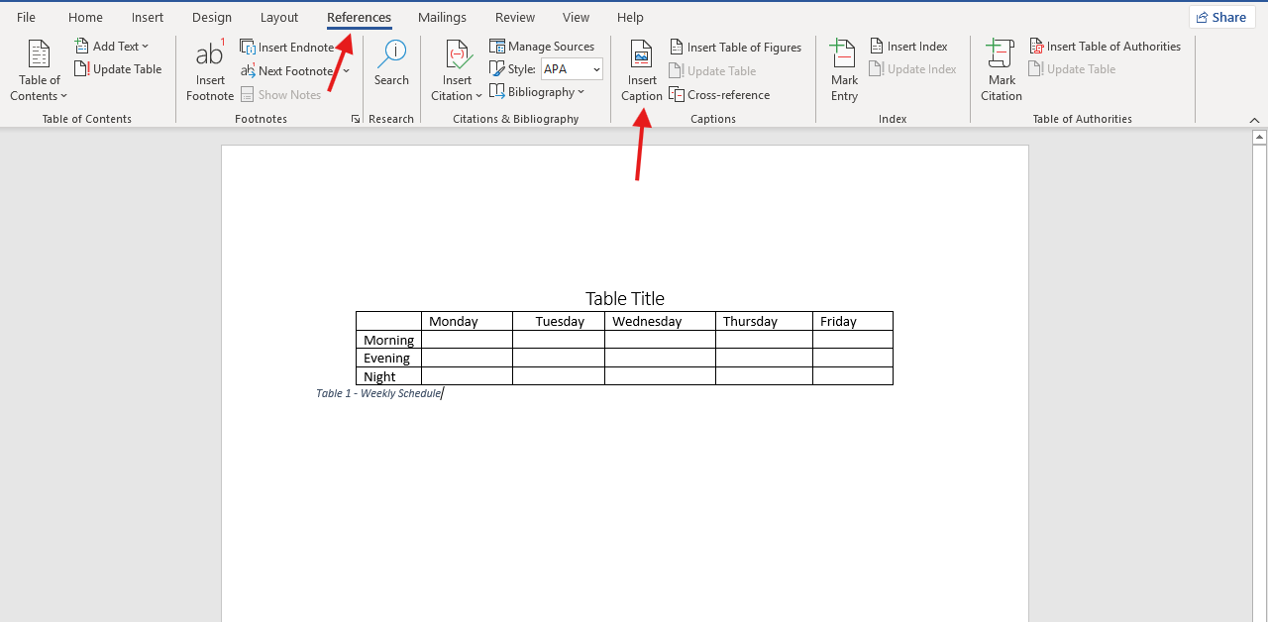

Step 4. Add a Caption (continued)
- A small tab will open.
- Choose Table for the Label option.
- Choose either below or above selected item for the Position option.
- Click OK.
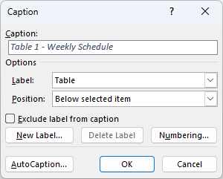

Most Common Mistakes:
- Missing Header Row - Screen readers cannot properly associate data cells with their column meaning.
- Merged Cells - Merged cells break the logical relationship between rows and columns, making navigation difficult for assistive technology
- Blank Headers - Screen readers rely on header text to announce context.
- Irregular Structure - Inconsistent structure prevents accurate screen reader navigation.
- Images of Tables Instead of Real Tables - Screen readers cannot interpret images of text unless properly described.

