How to Add Alt Text to Images in Canvas

Step 1: Edit Your Page
Open the Canvas page where you want to add or change an image and click the Edit button in the top right corner.
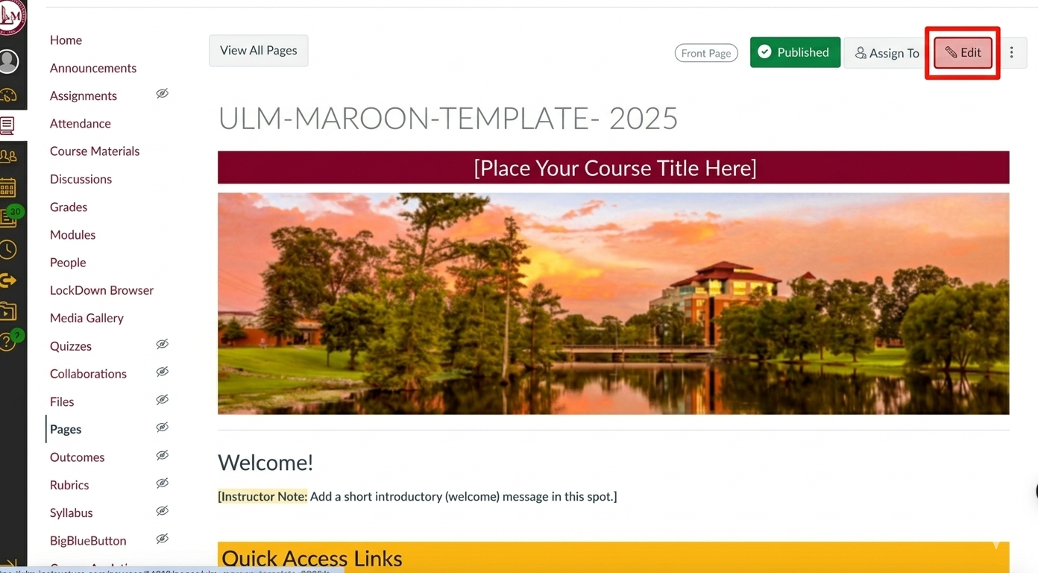

Step 2: Select the Image
Click directly on the image you have inserted into the rich content editor. A small menu will appear above or below the image. Click on Image Options
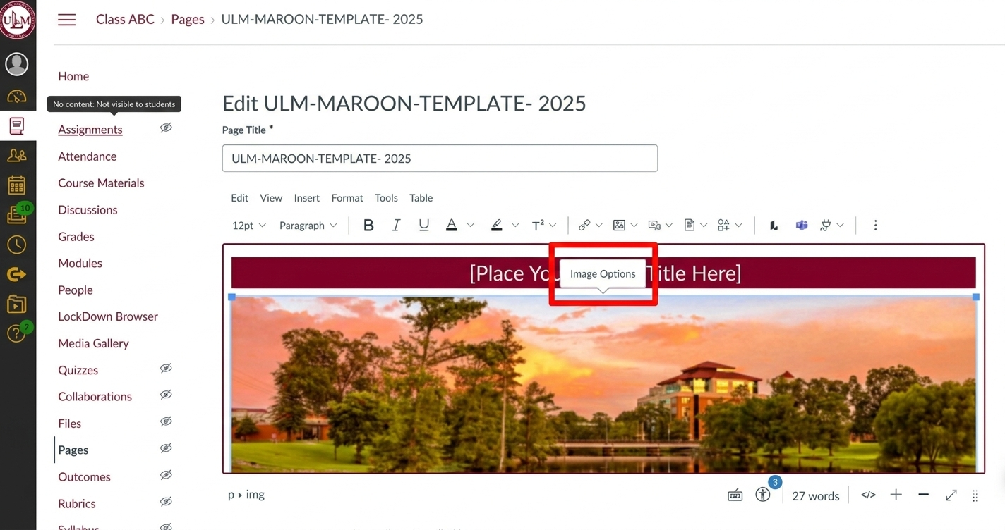

Step 3: Enter Alternative Text
A sidebar will open on the right side of the screen. Locate the Alt Text box and type a clear, concise description of what is happening in the image.
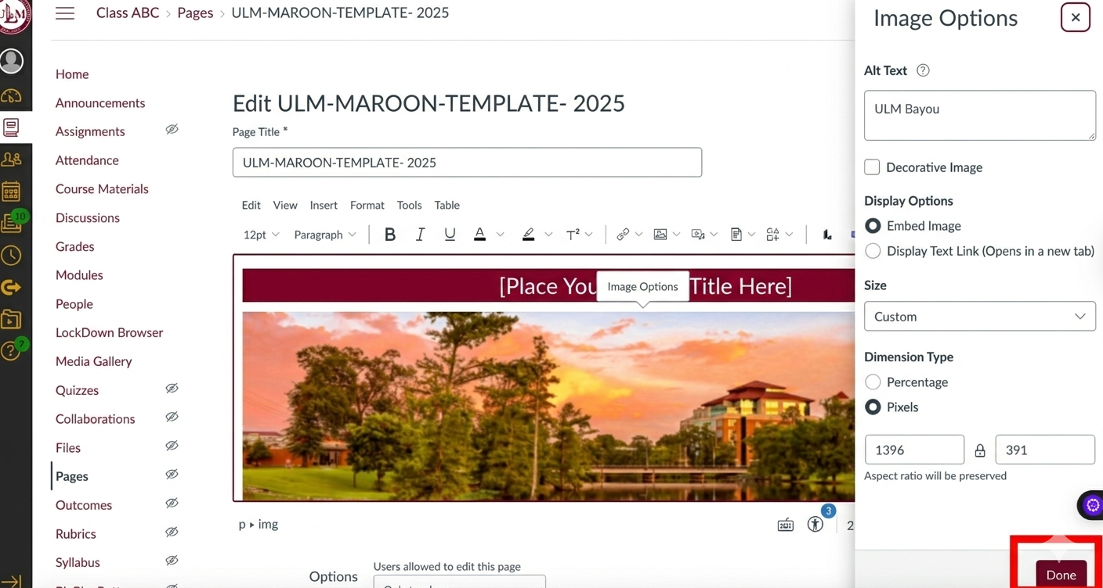

Step 4: Save Your Changes
Click the Done button at the bottom of the sidebar to apply the text, then click Save at the bottom of the Canvas page to finish.

Why This Matters
Alt text ensures that students with visual impairments using screen readers can understand the content and purpose of your images. Providing these descriptions creates an inclusive learning environment and ensures your course meets web accessibility standards.

Common Mistakes
- Using "Image of" or "Picture of": Screen readers already identify the item as an image, so these words are repetitive.
- Leaving it blank: Unless it is a decorative line or shape, a blank box forces screen readers to read the confusing file name aloud.
- Being too short: Using a single word like "Chart" doesn't explain what the data actually shows.

