How to check slide reading order in PowerPoint

Why does it matter?
Ensuring the correct reading order in PowerPoint slides is essential for students who use screen readers and other assistive technologies. Screen readers read slide content in a specific sequence based on the slide reading order. If the order is incorrect, the information may be read out of sequence, making the slide confusing or difficult to understand. By checking and correcting the reading order, instructors help ensure that all students—including those with visual impairments—can access and understand course materials. This practice supports inclusive teaching and helps ensure course content meets accessibility requirements in Canvas.
Step 1- Open Your PowerPoint File
- Launch PowerPoint
- Open the presentation you plant to upload into Canvas
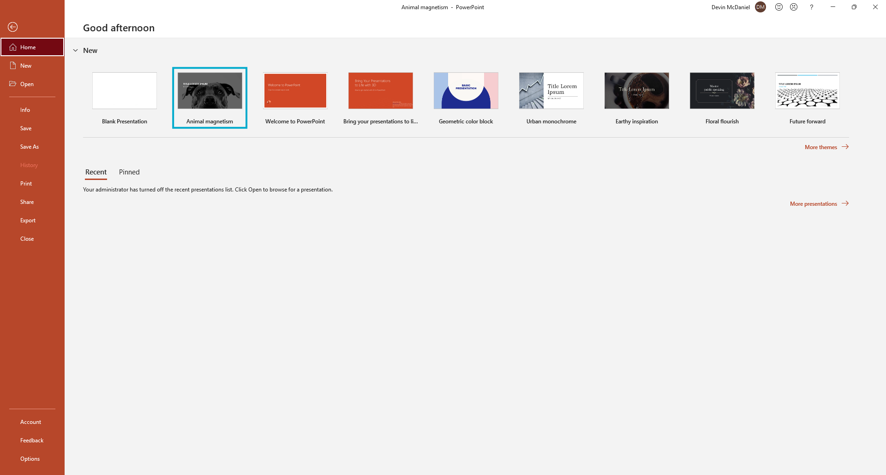In this image, PowerPoint was opened, and the presentation of interest was selected (blue box).

Step 2- Open the Selection Pane
- Click the Home tab in the ribbon.
- In the Arrange group, click Arrange
- Select “Selection Pane”
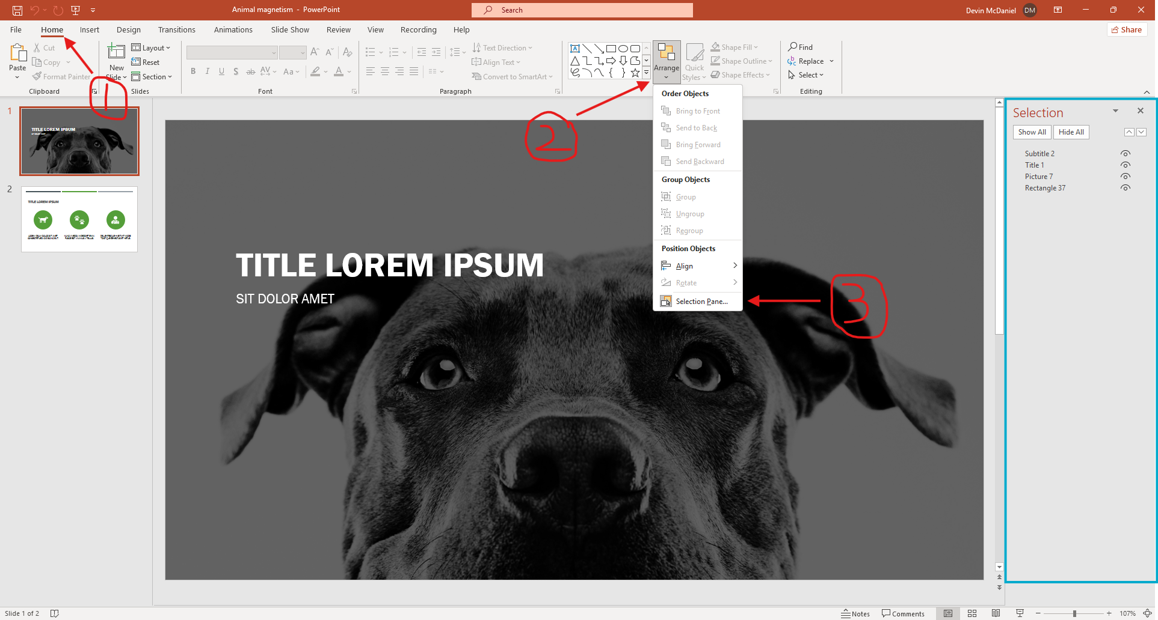The Selection Pane (blue box) will appear on the right side of the screen. It lists all objects on the current slide.

Step 3- Understand the Reading Order
- Expand the drop-down box of the “Check Accessibility” group.
- Select reading order pane
  - On the right side of the screen (green box), you can adjust the reading order and preview the text of what will be read aloud.
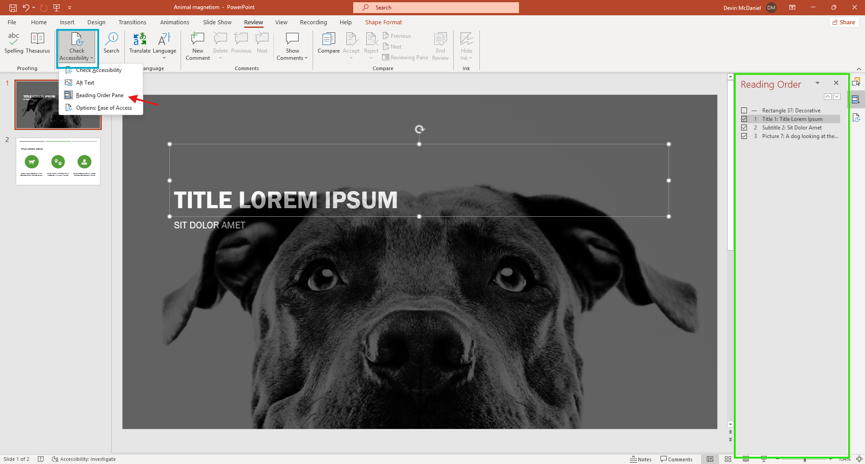
Step 4- Check the order of slide elements
- Look at the list of objects in the Selection Pane
- Click each item to highlight it on the slide so you know what it is.
- Confirm that the order makes sense for someone listening to the slide with a screen reader.
Step 5- Reorder slide objects if needed
- In the image above, the reading order is already correct; however, it can be changed to whatever order is desired.
Slide 6- Repeat for each Slide
- Move to the next slide in your presentation.
- Open the Reading pane if it is not already visible
- Check and adjust the reading order as needed.
Step 7- Run the Accessibility Checker
- Click on the Review tab.
- Select Check Accessibility
- Review any accessibility warnings and correct them.
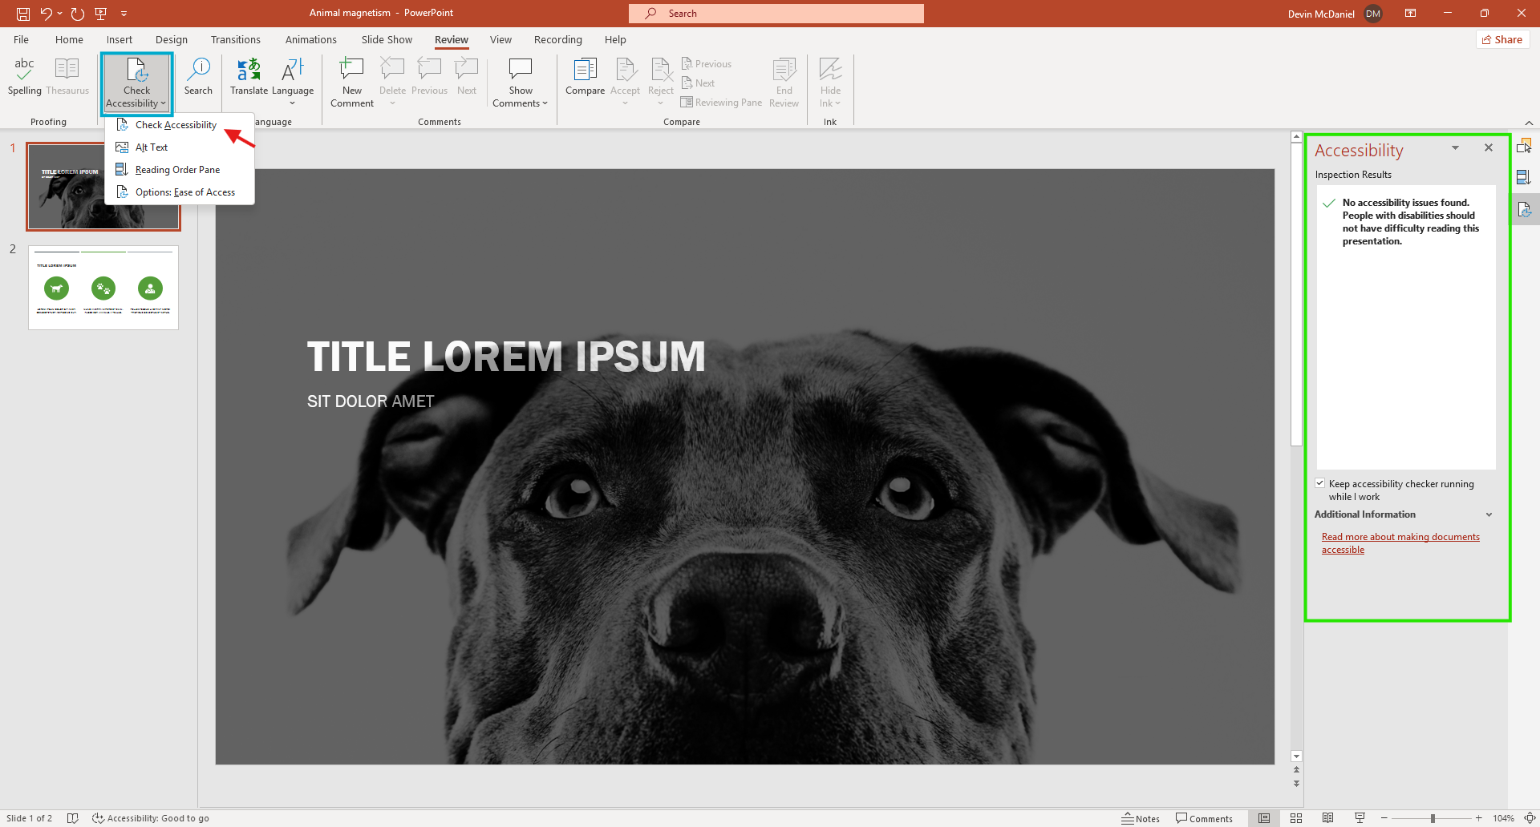

Common Mistakes
- Title is not read first
- Text boxes added outside the slide layout
- Images read before important text
- Decorative objects being read by screen readers
- Content read out of logical sequence
- Grouped objects creating confusing order
- Not checking every slide
- Overlapping text boxes
Tip: Using PowerPoint’s built-in slide layouts helps maintain a logical reading order automatically and reduces many of these common accessibility issues

