http://www.mcschools.net/neville Neville High School

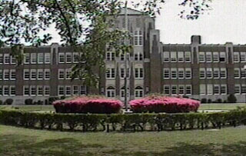

http://www.mcschools.net/cpu Cypress Point University School

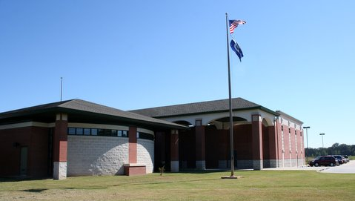

http://mcschools.net/lincoln Lincoln Elementary School

