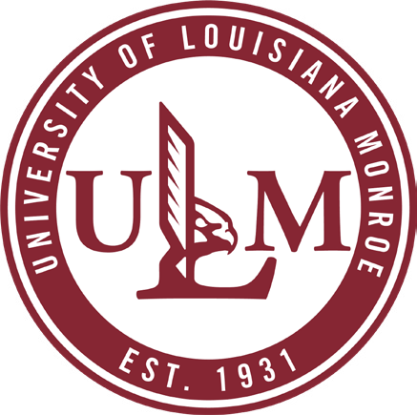
College of Health Sciences

Personal and Virtual Open House

WHEN

Date: November 11, 2022

Time: 9:00 a.m.

WHERE

Sugar Hall 101

Register online at:

Speech-Language Pathology Open House

If you are unable to attend in person or
via Zoom, contact us for more information

slp@ulm.edu 318-342-1392

MASTER OF SCIENCE
SPEECH-LANGUAGE PATHOLOGY

What to expect:

An overview of the academic and clinical programs.
Application process.
Meet our faculty.
Financial Aid and housing.

The Monroe/West Monroe, Louisiana area.

Questions and Answers.

Meet our students.

Clinic Tour.

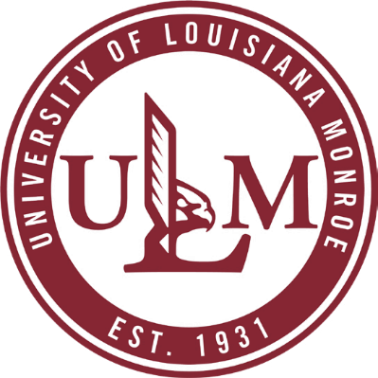
ulm.edu/slp

