**Welcome E-mail**

To access the Works application, a Program Administrator must add you as a user and assign you a username. Once you have been added to the system, a welcome email will automatically be sent to your email address that includes your username and information on how to set up your password.

Follow the instructions in the email.



**LOG ON INSTRUCTIONS**

**Login to Works:**

* Go to the following web address: <http://www.bankofamerica.com/worksonline>
* Bookmark the login screen once it appears on your desktop, for ease of access in the future.
* Enter the email address associated with your “Login Name” and “Password” in order to access Works.

Complete the Login Name and Password fields with your current login/password.

**Forgotten Password**

Complete the Login Name, click **Forgot your password?**

Enter the email address and Login Name

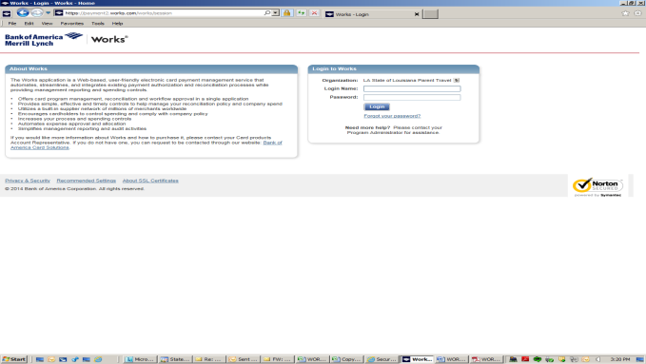

**ACCOUNTHOLDER INSTRUCTIONS**

This guide provides information needed for an accountholder to manage transactions. Within this guide, you will learn how to:

* Allocate or edit a transaction and enter a description
* Sign off on a transaction
* Dispute a transaction
* Remove a flag on a transaction
* View Authorization Log

Each of the above topics includes step-by-step instructions for performing a specific task. You can review all of the tasks in this guide or review the task that is specific to your interest.

**Allocate or Edit a Transaction and Enter a Description**

**Procedure:**

1. On the **Home Page** under **Action Items>Current Status**, click on the **Pending** link.

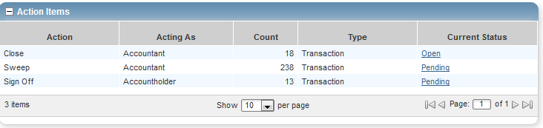

These are the transactions ready for accountholder or approver sign off.

1. Click the desired **Document** number**.** A menu displays.

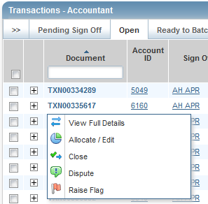

1. Select **View Full Details.** The **Transaction Detail** screen displays.

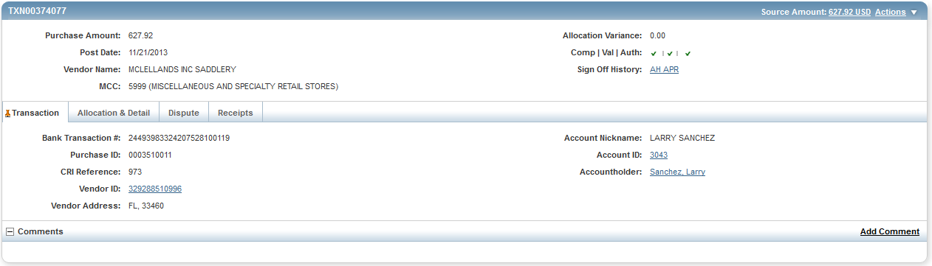

1. Select the **Allocation & Detail** tab.

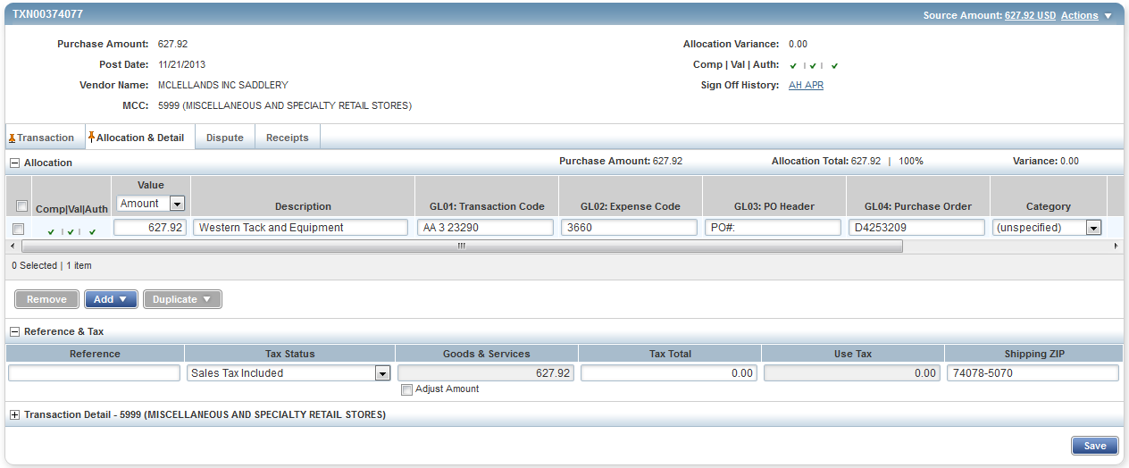

1. Select the **Allocation & Detail** tab, edit, if applicable. Enter codes in the following fields to identify how the segment will be allocated

* GL01: Fund/Agency/Organization
* GL02: Activity
* GL03: Object
* GL04: Sub-Object
* GL05: Agency/Reporting Category

1. To add additional lines of funding, click on the **Add** button and choose how many additional lines you need.

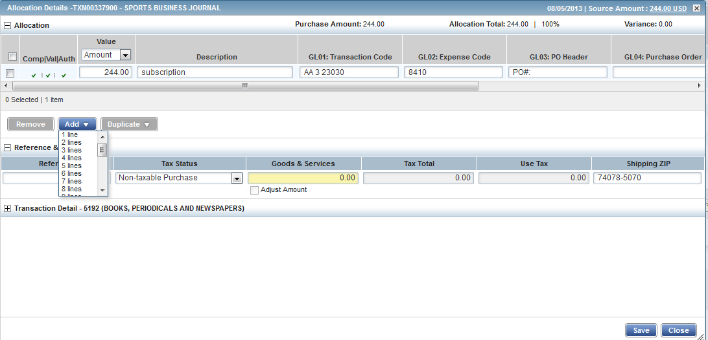

1. Fill in the amount, description, account number, and coding for the additional lines of funding.

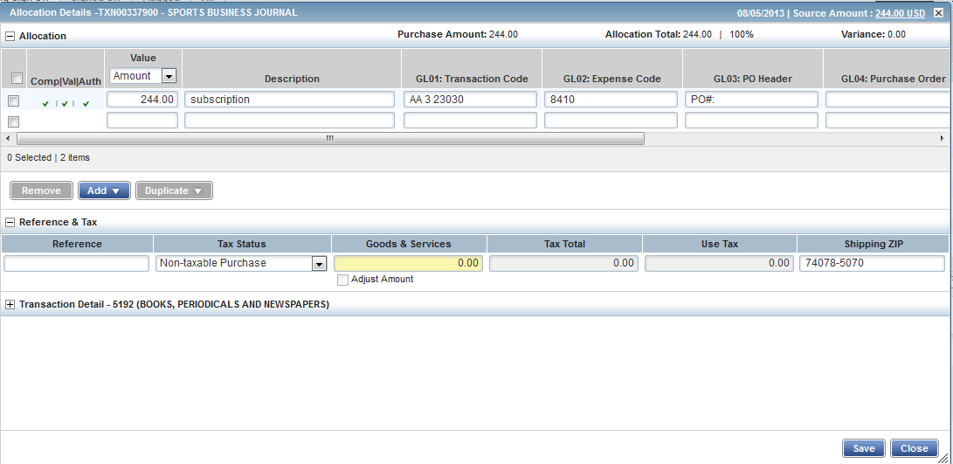

1. Click **Save**.
2. In the upper right corner of the **Allocation & Detail** tab, click on the **Actions** drop down menu.

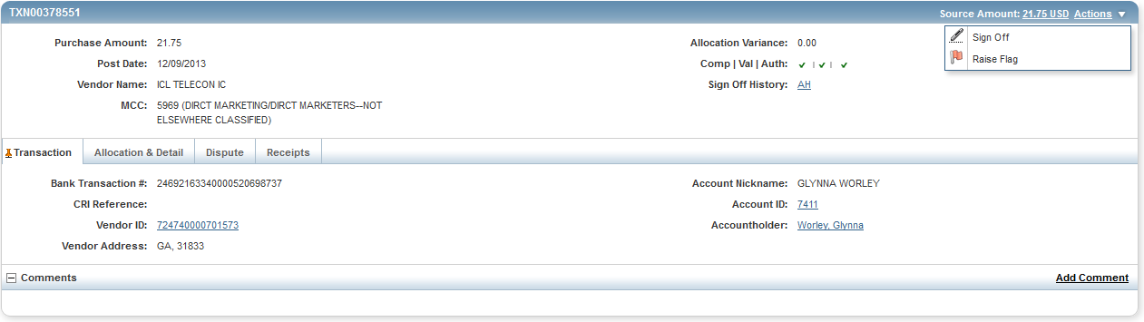

1. Click **Sign Off**. The **Confirm Sign Off** screen displays enter a description of the transaction.

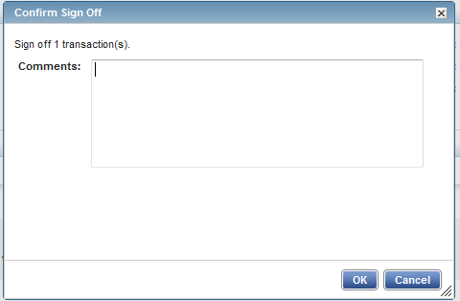

1. Click **OK**.
2. This completes the procedure.

**Disputing a Transaction**

**NOTE:**

* Accountholders will only be able to dispute their transactions
* Approvers/Managers/Supervisors will only be able to dispute for accountholders they have been assigned to approve, depending on the agency workflow configuration.
* Accountants will be able to dispute Accountholders transaction after the transaction has been swept.

**Procedure:**

To dispute a transaction, complete the following:

1. On the **Home Page** under **Action Items>Sign Off>Current Status**, click on the **Pending** link.



1. Click the desired **Document** number. A drop-down menu displays.

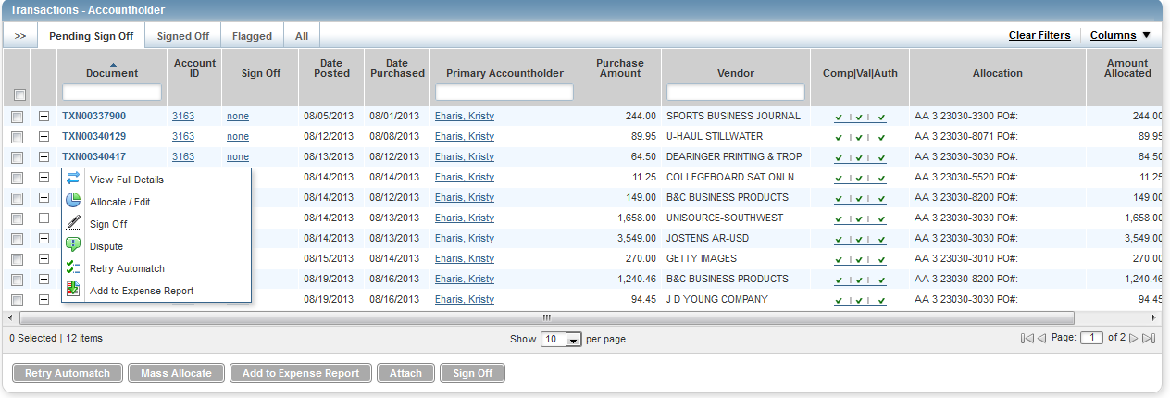

1. Click **Dispute**. The **Dispute Transaction** screen displays.

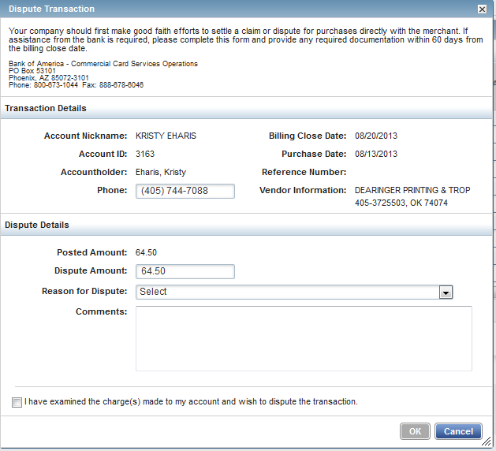

1. Enter the **Dispute Amount**, if different from the purchase total.
2. Select the **Reason for Dispute** from the drop-down menu.

**Note:** Depending on the **Reason for Dispute**, additional information may be required.

1. Enter **Comments**, if desired.
2. Select the **I have examined the charge(s) made to my account and wish to dispute the transaction** check box.
3. Click **OK**. The screen displays a confirmation message.
4. This completes the procedure.
5. NOTE: You must inform your agency LaCarte Program Administrators that you have a dispute

**Remove Flag**

To remove a flag, complete the following:

1. On the **Home Page** under **Action Items>Current Status**, click on the **Flagged** link.

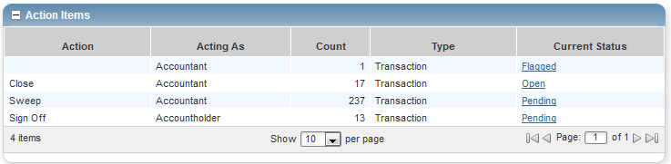

1. Select the check box for the **Document** you wish to “un-flag.” The action buttons at the bottom of the screen become enabled.

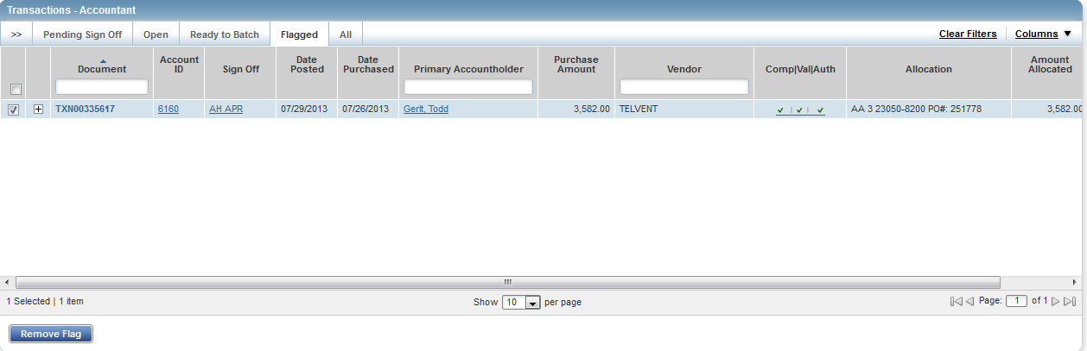

1. Click **Remove** **Flag**. The **Confirm Remove Flag** window displays.

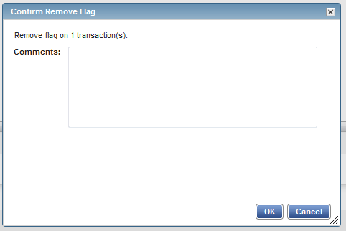

1. Enter a **Comment.** You will not be able to remove the flag unless you enter a comment.
2. Click **OK**.
3. This completes the procedure.

**VIEW AUTHORIZATION LOG**

The Authorization Log allows you to see transactions that have been approved by the bank but have not yet posted to Works; if a transaction was declined, the reason why is shown.

1. On the **Home Page**, **Accounts Dashboard**, click on the last 4 digits of your account ID.

**NOTE: The Accounts Dashboard also lists your credit limit, balance, and available credit. This is useful information easily referenced on the Works Home Page.**

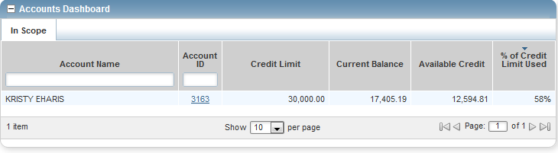

1. Click on the **Actions** link in the upper right corner**.**

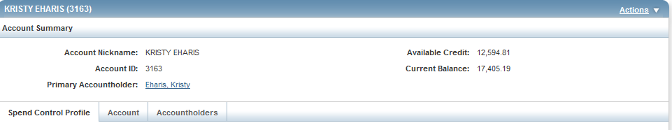

1. Click **View Auth Log**.

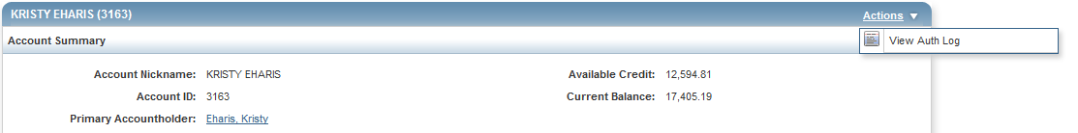

1. The next screen will be your **Authorization Log**.

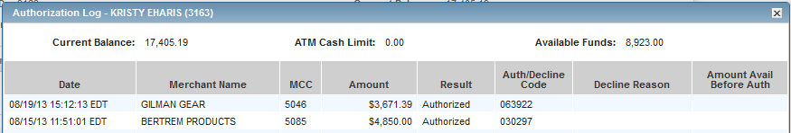

**SEARCHING AND SORTING TRANSACTIONS**

This guide provides information on searching and sorting transactions. Within this guide, you will learn how to:

* Search for a transaction
* Sort transactions

**The Transaction Screen**

**NOTE: Screen shots will be from the accountant’s point of view, but the information available is the same for any user.**

**Procedure:**

**To look at your transactions, complete the following:**

1. On the **Home Page** go to **Expenses>Transactions>(Accountholder, Approver or Accountant).** Click on the appropriate role.

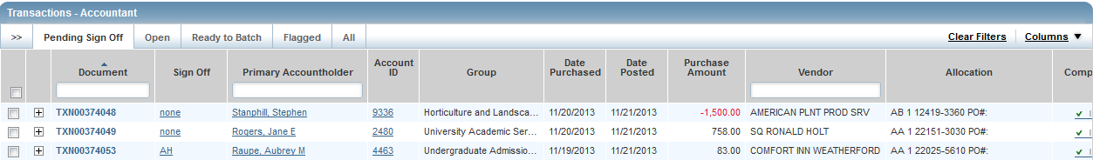

The **Pending** tab is the default tab that shows up.

1. **Pending** transactions are transactions awaiting accountholder or approver sign off.
2. **Open** transactions are transactions awaiting accountant signature. (Only accountants have access to this tab.)
3. Transactions **Ready to Batch** are transactions that have been signed off on by the accountholder, approver, and accountant. They have not yet been locked and downloaded into SCT. (Only accountants have access to this tab.)
4. **Flagged** transactions are transactions that have been returned to the accountholder for clarification.
5. **All** is your transaction history. You can search for any transaction you are allowed to see as far back as the transaction remains on Works, approximately two years.
6. Accountholders have access to the **Signed Off** tab. This tab shows all transactions the cardholder has signed off on.

**To view transaction details:**

1. Click on the **Document (TXN)** number.

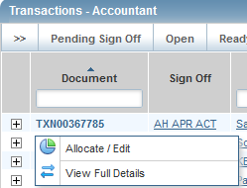

1. You can choose to view the **Allocate/Edit** screen, or the **View Full Details** screen. Either screen will allow you to view the details of a transaction.

**Allocate/Edit screen**

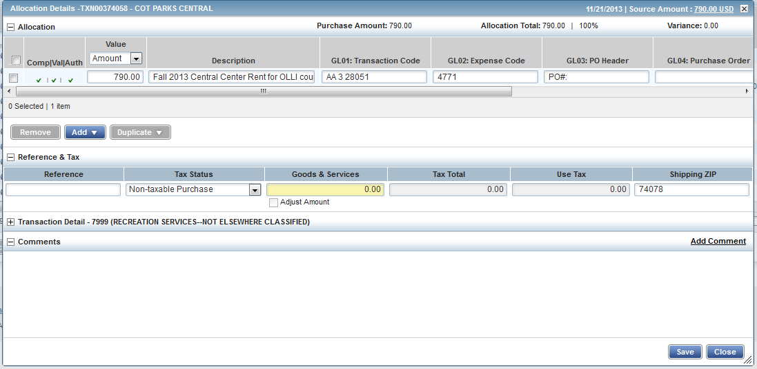

**View Full Details Screen**

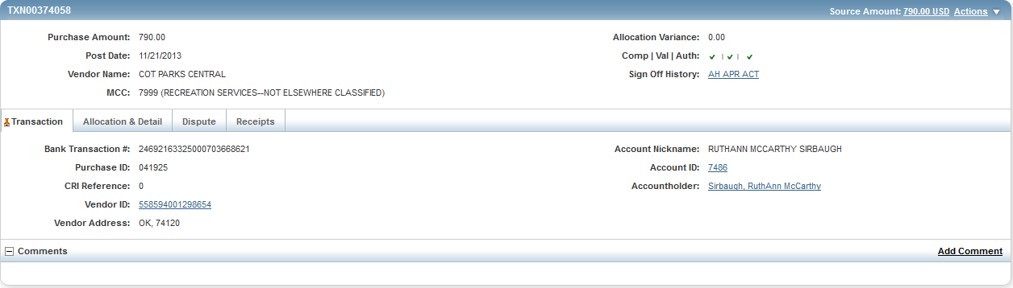

From both screens you will be able to see details of the transaction. You can click on any plus sign or tab for more details. In addition, anything in blue is a hyperlink.

**To customize the columns on the transaction screen:**

1. Click on the **Columns** menu in the upper right corner of the **Transaction** screen.

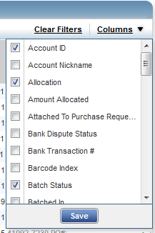

1. Place a checkmark by the columns you wish to appear on your screen. Remove the checkmark from any columns you don’t need.
2. Click the save button.
3. You can change the order of the columns by placing your cursor in the column heading, holding the button on the mouse down and moving the column where you want it to be.

**To search for a specific transaction:**

1. You can search using the column headers or the blank fields.



1. You can search by document (TXN), accountholder or vendor by typing in the blank fields.
2. By clicking in the header field you sort transactions by that field. Another click in the header field will reverse sort.
3. You can also filter transactions by clicking on the double arrows in the upper left corner of the **Transaction** screen.

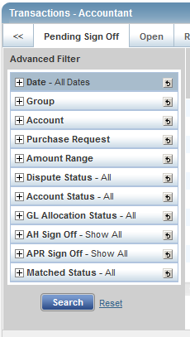

This is the **Advanced Filter** and can be used to search for transactions by date, group, account, etc.

1. The default number of transactions that shows on the screen is 10. You can reset the number of transactions by clicking on the button in the bottom center of the transaction screen and choosing another number.



You can choose 10, 25, 50, 75, 100, 250, or 500. One of the drawbacks of Works is that you have to reset your filters every time you leave the screen and come back to it.

1. Remember, anything in blue is a hyperlink.

**How to look at a list of transactions:**

There may be times when you want to sort and look at a list of transactions. Once you look at the details of one transaction, you can’t go back to the screen without resetting your filters. This trick will help you avoid that.

1. Pull up a list of transactions you want to review.

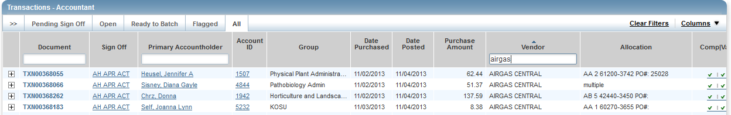

2. Left click on the **Document** number.

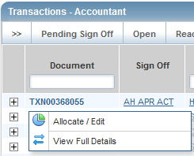

1. Right click on either **Allocate/Edit** or **View Full Details.**
2. This will bring up a pop up box. Choose **Open Link in New Tab**.
3. This will open the detail for this transaction in a new tab at the top of your screen.

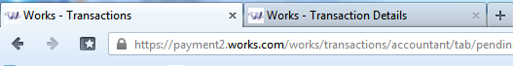

1. Click on the new tab (**Works-Transaction Details**) and look at the details of the transaction. When you’re finished, close this tab and go back to your original list of transactions. Choose another transaction to look at the same way.
2. By looking at transactions in this manner, you will not have to reset your filters every time you look at a transaction.

**APPROVER INSTRUCTIONS**

This guide provides information needed for an approver to manage transactions. Within this guide, you will learn how to:

* Review and sign off on a transaction

**Review and Sign Off on a Transaction**

**NOTE: Approvers are usually not required to edit the account number or enter a description. The approver should review the transaction to determine that it is a reasonable, appropriate and legitimate transaction for the department. If you are required to edit the account number and subcodes, see the instructions for accountholder.**

**Procedure:**

To review a transaction, complete the following:

1. On the **Home Page** under **Expenses>Transactions>Approver**, click on the **Pending** link. The **Pending Sign Off** screen is displayed.

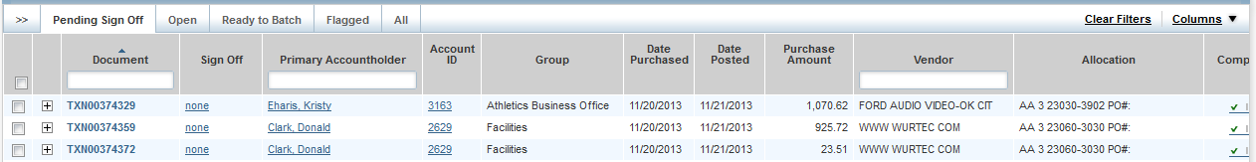

1. Click the desired **Document** number**.** A menu displays.

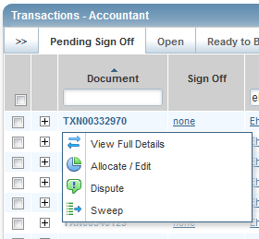

1. Select **View Full Details**. The **Transaction Details** screen displays.

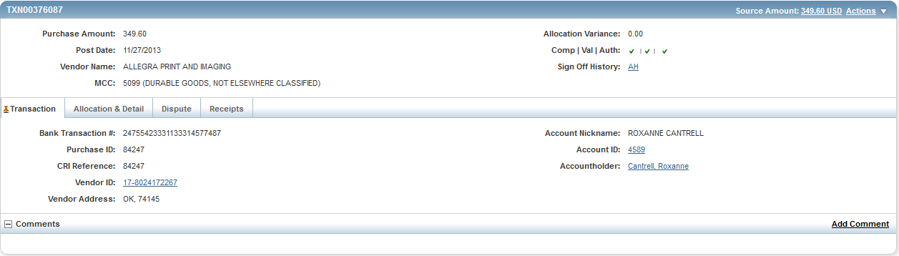

1. Select the **Allocation & Detail** tab.

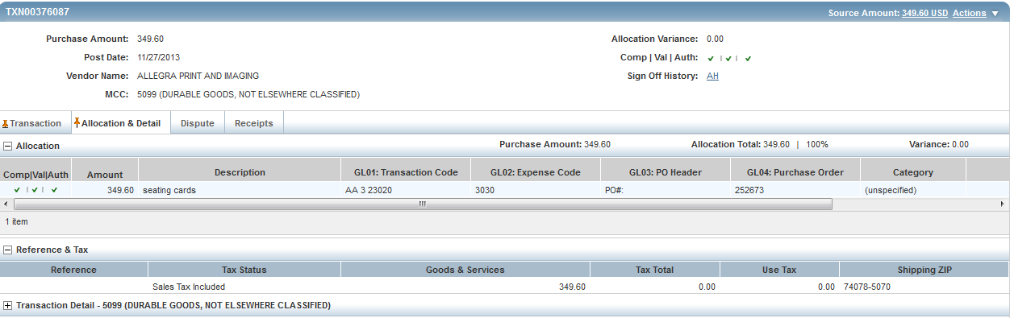

1. Read the description entered into the **Description** field by the accountholder. To the best of your ability determine if this is a reasonable, authorized, legitimate transaction for the University, and the account number and subcode are correct.
2. In the upper right corner of the **Allocation & Detail** tab, click on the **Actions** drop down menu.



1. Click **Sign Off**. The **Confirm Sign Off** screen displays.



1. Click **OK**.
2. This completes the procedure.

**ACCOUNTANT INSTRUCTIONS**

This guide provides information needed for an accountant to manage transactions. Within this guide, you will learn how to:

* Allocate or edit a transaction
* Close a transaction
* Sweep a transaction
* Manage flags on a transaction

Each of the above topics includes step-by-step instructions for performing a specific task. You can review all of the tasks in this guide or review the task that is specific to your interest.

**Allocate or Edit a Transaction**

**Procedure:**

1. On the **Home Page** under **Action Items>Current Status**, click on the **Open** link.



These are the transactions ready for accountant sign off.

1. Click the desired **Document** number**.** A menu displays.



1. Select **View Full Details.** The **Transaction Detail** screen displays.



1. Select the **Allocation & Detail** tab.



1. The cardholder should have entered a description of what was purchased and the business purpose. Make sure this makes sense and is an allowable purchase.
2. Make sure the account number and codes are correct. If not, highlight and make the corrections.
3. To add additional lines of funding, click on the **Add** button and choose how many additional lines you need.



1. Fill in the amount, description, account number, and subcode for the additional lines of funding.



1. Click **Save**.
2. In the upper right corner of the **Allocation & Detail** tab, click on the **Actions** drop down menu.

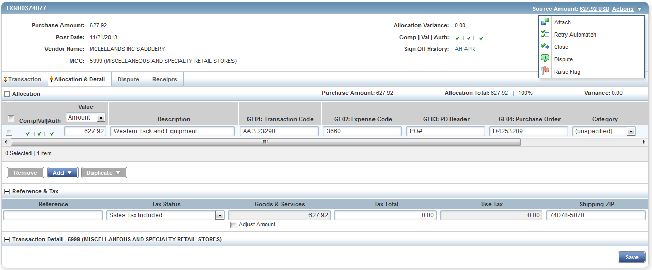

1. Click **Close**. The **Confirm Close** screen displays.

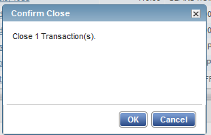

1. Click **OK**. The closed transaction moves to the **Ready to Batch** screen.
2. This completes the procedure.
3. If you need to correct any coding after you have closed a transaction, you can find the transaction under the **Ready to Batch** tab until it has been downloaded and locked by University Accounting.

**Sweeping a Transaction**

Accountants can move transactions from their Pending Sign Off queue into their Open queue when accountholders and/or approvers have not signed off on a transaction. This allows the accountant to sign off on a transaction and verify and/or correct the accounting information when the accountholder or approver have not, or are unable to, sign off on a transaction. After the sweep occurs, neither the accountholder nor the approver may edit the transaction’s allocation codes or enter a description.

**Procedure:**

To sweep a transaction, complete the following:

1. On the **Home Page** under **Action Items>Sweep>Current Status**, click on the **Pending** link.



These are the transactions awaiting accountholder and/or approver sign off.

1. Select the check box for each **Document** you wish to sweep. The action buttons at the bottom of the screen become enabled.

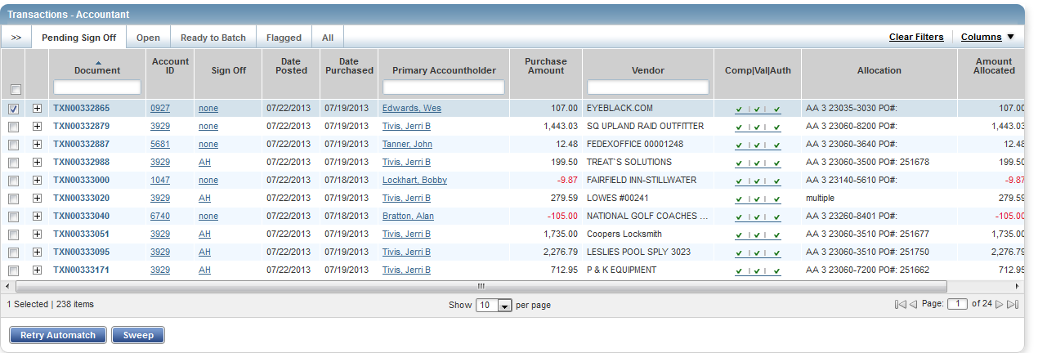

1. Click **Sweep**. The **Confirm Sweep** window displays.

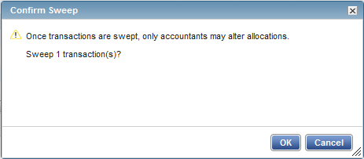

1. Click **OK**. The transaction moves to the **Open** tab and is ready for accountant signoff.
2. This completes the procedure.

**NOTE:** Even though the accountant can now sign off on the transaction, the transaction will remain on the accountholder and/or the approver screen for their sign off. The accountholder’s credit limit will not be refreshed for the amount of the transaction until both accountholder and approver have signed off on the transaction.

**Managing Flags**

Flags indicate transactions needing attention. Flagging the transaction sends it back to the Accountholder for a response. Once the transaction is reviewed and action taken, the flag is removed.

**Notes:**

* An Accountant can flag a transaction to alert other users there is an issue or question with a transaction.
* Flagging a transaction does not prevent an Accountant from closing the transaction.
* Flagging a transaction does not change its location in the workflow.

**Procedure:**

To manage flags, complete the following:

1. On the **Home Page** under **Action Items>Current Status**, click on the **Open** link.



1. Select the check box for the **Document** you wish to flag. The action buttons at the bottom of the screen become enabled.

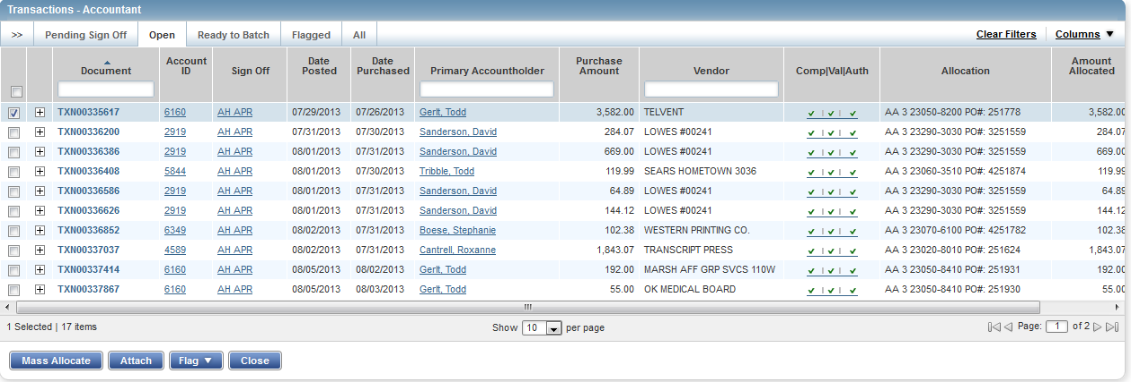

1. Click **Flag**. A drop-down menu displays.

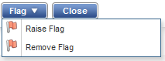

1. Select **Raise Flag**.
2. Enter a comment.

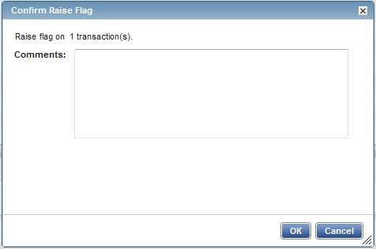

1. Click **OK**. This sends the transaction back to the accountholder for a response.
2. This completes the procedure.

**Remove Flag**

To remove a flag, complete the following:

1. On the **Home Page** under **Action Items>Current Status**, click on the **Flagged** link.



1. Select the check box for the **Document** you wish to “un-flag.” The action buttons at the bottom of the screen become enabled.



1. Click **Remove** **Flag**. The  window displays.



1. Enter a **Comment.** You will not be able to remove the flag unless you enter a comment.
2. Click **OK**.
3. This completes the procedure.