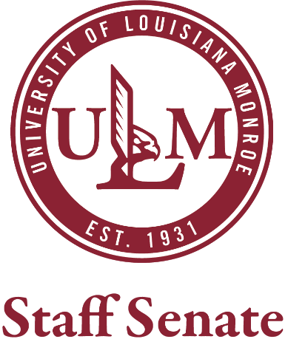
January 18, 2023
Call to Order

Roll Call

Approval of the November Minutes

Committee Reports

Guest Speaker: Miss ULM

Unfinished Business

New Business
- CAB/SGA Sponsored meals
- Senate Resolution regarding deceased staff members
- Volunteer/Service hours implementation
- New finance committee
- Shared governance meeting 1/23

Adjournment

Next meeting date February 15, 2023

