Northern Mockingbird | X | X | X | X
Brown Thrasher | X | X | X | X
Cedar Waxwing |  |  |  | X
Blue-winged Warbler | X
Tennessee Warbler | X
Orange-crowned Warbler |  |  |  | X
Northern Parula | X | X
Chestnut-sided Warbler | X
Magnolia Warbler | X
Yellow-rumped Warbler | X |  |  | X
Pine Warbler |  |  |  | X
Prairie Warbler | X
Black-and-white Warbler | X
American Redstart | X
Prothonotary Warbler | X | X
Worm-eating Warbler | X
Kentucky Warbler | X | X
Common Yellowthroat | X | X | X | X
Hooded Warbler | X | X
Yellow-breasted Chat | X | X
Summer Tanager | X | X
Scarlet Tanager | X
Eastern Towhee | X | X | X | X
Chipping Sparrow | X |  | X | X
Field Sparrow |  |  |  | X
Savannah Sparrow |  |  | X | X
Song Sparrow |  |  | X | X
Swamp Sparrow |  |  | X | X
White-throated Sparrow |  |  | X | X
Dark-eyed Junco |  |  | X | X
Northern Cardinal | X | X | X | X
Rose-breasted Grosbeak | X
Blue Grosbeak | X
Indigo Bunting | X | X
Painted Bunting | X | X
Dickcissel | X | X
Bobolink | X
Red-winged Blackbird | X | X | X | X
Eastern Meadowlark | X | X | X | X
Western Meadowlark | X
Common Grackle | X | X | X | X

Brown-headed Cowbird | X | X | X | X
Orchard Oriole | X | X
Baltimore Oriole | X | X |  | X
Purple Finch |  |  |  | X
House Finch (I) | X |  |  | X
Pine Siskin |  |  |  | X
American Goldfinch |  |  | X | X

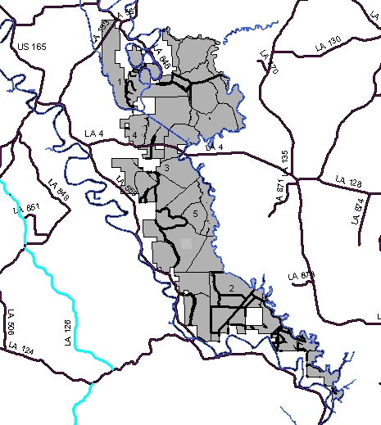
Top Birding Locations
- Rookery & North End Trail
- Enterprise tract
- Southern Campground
- WRP Fields
- Central Trail
Boeuf
Wildlife Management Area
Columbia, LA

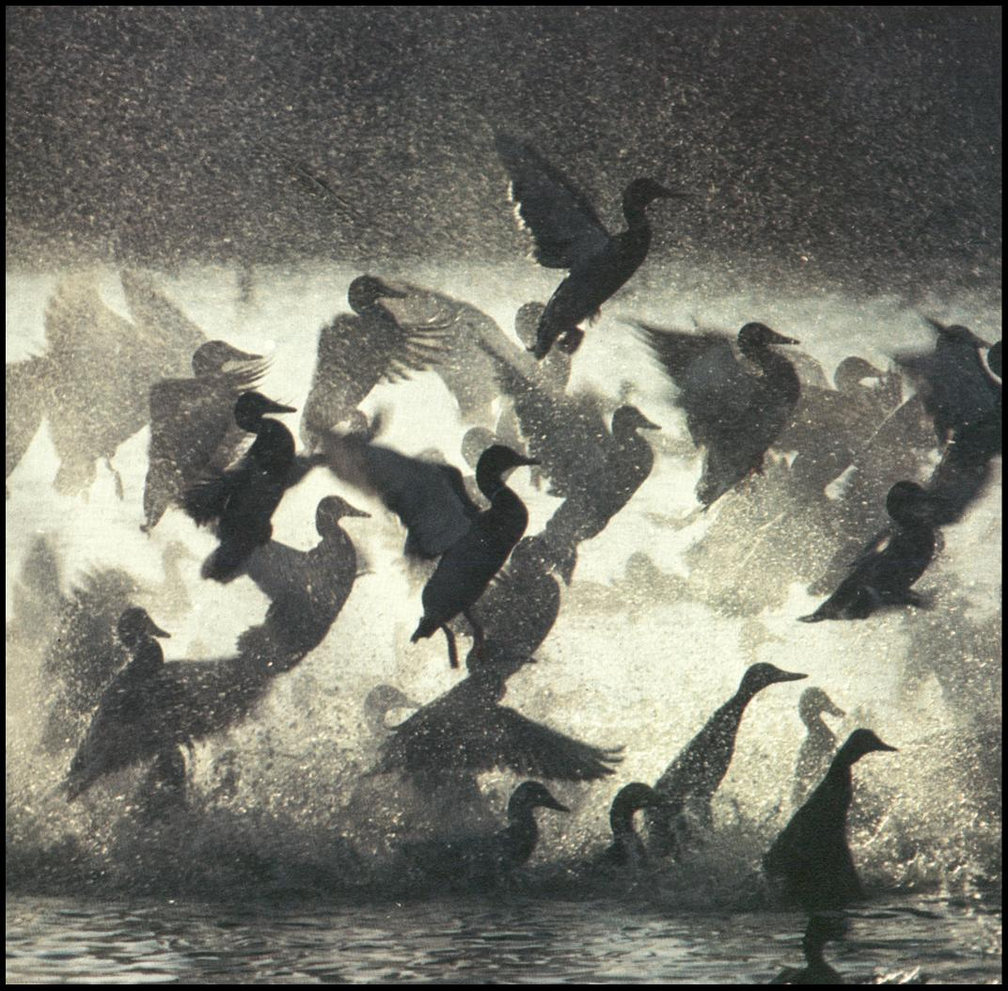
Photo by Thomas Rosburg

A seasonal bird list

In collaboration with
University of Louisiana at Monroe
&
Louisiana Dept of Wildlife and Fisheries

Compiled 2004-2005
by John Quinn

 | Spring Migration | Summer | Fall Migration | Winter
Greater White-fronted Goose |  |  |  | X
Snow Goose |  |  |  | X
Wood Duck | X | X | X | X
Gadwall |  |  | X | X
American Wigeon |  |  | X | X
American Black Duck | X | X
Mallard | X |  | X | X
Blue-winged Teal | X |  | X | X
Northern Shoveler | X |  | X | X
Northern Pintail |  |  | X | X
Green-winged Teal | X |  | X | X
Canvasback |  |  | X | X
Redhead |  |  | X | X
Ring-necked Duck | X |  | X | X
Lesser Scaup |  |  | X | X
Hooded Merganser |  |  | X
Wild Turkey | X | X | X | X
Northern Bobwhite | X | X | X | X
Pied-billed Grebe | X | X | X | X
American White Pelican | X |  |  | X
Double-crested Cormorant |  |  | X | X
Anhinga | X | X
American Bittern | X
Great Blue Heron | X | X | X | X
Great Egret | X | X | X | X
Snowy Egret | X | X |  | X
Little Blue Heron | X | X | X
Tricolored Heron | X | X
Cattle Egret | X | X
Green Heron | X | X
Black-crowned Night-Heron | X | X
Yellow-crowned Night-Heron | X | X
White Ibis |  | X | X
Glossy Ibis |  | X | X
White-faced Ibis |  | X | X
Roseate Spoonbill |  | X | X
Wood Stork |  | X
Black Vulture | X | X
Turkey Vulture | X | X | X | X
Osprey |  |  |  | X
Mississippi Kite | X | X
Bald Eagle |  |  |  | X
Northern Harrier |  |  | X | X
Sharp-shinned Hawk | X | X
Cooper's Hawk | X
Red-shouldered Hawk | X | X | X | X
Broad-winged Hawk |  | X
Red-tailed Hawk | X | X | X | X
American Kestrel |  | X | X | X
Sora | X | X
Common Moorhen | X | X |  | X
American Coot | X | X | X | X
Black-bellied Plover | X
Killdeer | X | X | X | X
Black-necked Stilt |  | X | X
American Avocet |  | X | X
Greater Yellowlegs | X | X | X | X
Lesser Yellowlegs | X | X | X
Solitary Sandpiper |  |  | X
Spotted Sandpiper | X |  | X
Semipalmated Sandpiper | X |  | X
Western Sandpiper | X |  | X
Least Sandpiper | X |  | X
Pectoral Sandpiper | X
Stilt Sandpiper |  |  | X
Short-billed Dowitcher | X
Wilson's Snipe | X |  |  | X
American Woodcock | X |  |  | X
Wilson's Phalarope | X
Caspian Tern |  |  | X
Common Tern |  |  | X
Mourning Dove | X | X | X | X
Yellow-billed Cuckoo | X | X
Eastern Screech-Owl |  | X
Great Horned Owl | X | X | X | X
Barred Owl | X | X | X | X
Common Nighthawk | X | X
Chimney Swift | X | X
Ruby-throated Hummingbird | X | X
Belted Kingfisher | X | X | X | X
Red-headed Woodpecker | X | X | X | X
Red-bellied Woodpecker | X | X | X | X
Yellow-bellied Sapsucker |  |  |  | X
Downy Woodpecker | X | X | X | X
Hairy Woodpecker | X | X | X | X
Northern Flicker | X | X | X | X
Pileated Woodpecker | X | X | X | X
Eastern Wood-Pewee | X | X
Acadian Flycatcher | X | X
Eastern Phoebe |  |  | X | X
Great Crested Flycatcher | X | X
Eastern Kingbird | X | X
Scissor-tailed Flycatcher | X |  | X
Loggerhead Shrike | X | X | X | X
White-eyed Vireo | X | X
Yellow-throated Vireo | X | X
Blue-headed Vireo |  |  |  | X
Red-eyed Vireo | X | X
American Crow | X | X | X | X
Fish Crow | X | X | X | X
Purple Martin | X | X
Tree Swallow | X | X
Northern Rough-winged Swallow | X | X
Barn Swallow | X | X
Carolina Chickadee | X | X | X | X
Tufted Titmouse | X | X | X | X
Brown Creeper |  |  | X | X
Carolina Wren | X | X | X | X
Winter Wren |  |  |  | X
Sedge Wren | X
Golden-crowned Kinglet |  |  |  | X
Ruby-crowned Kinglet |  |  |  | X
Blue-gray Gnatcatcher | X | X
Eastern Bluebird | X | X | X | X
Veery | X
Swainson's Thrush | X
Hermit Thrush | X |  |  | X
Wood Thrush | X | X
American Robin | X |  |  | X
Gray Catbird | X | X | X | X

